A Project Report on

# ANTI PLASTIC AWARENESS

## Submitted in partial fulfilment of the requirements for the award of the degree of

BACHELOR OF TECHNOLOGY

In

COMPUTER SCIENCE AND ENGINEERING

Submitted by:

GANTI PETERSON (23P31A0572)

BORA VENKAT PRAVEEN REDDY (23P31A0585)

BASWA BHAVANA SHANMUKHI (23P31A0596)

ANGULURI BABITHA ESTHER RANI (23P31A05A1)

GOGU VENNELA (23P31A05A5)

JORUNGU GOPAL RAO (23P31A05A6)

NALLA SIVANANDU (23P31A05C0)

VOLETI PAVAN TEJA (23P31A05C4)

DUGGUDURTHI SAI RAJANI (24P35A0513)

Under the esteemed supervision of

## Mr. JAGATHA S NARENDRA KUMAR

Sr. Assistant Professor M. Tech (PhD).



ADITYA COLLEGE OF ENGINEERING & TECHNOLOGY (A)

Approved by AICTE, New Delhi & Affiliated to JNTUK, Kakinada

Accredited by NAAC(A+) and NBA

Surampalem, Kakinada District, Andhra Pradesh – 533437

## COMMUNITY SERVICE PROJECT REPORT

Submitted in accordance with the requirement for the degree of B. TECH

**Name of the College**: ADITYA COLLEGE OF ENGINEERING AND

TECHNOLOGY

**Programme of Study: B. Tech**

**Name of the Department:** COMPUTER SCIENCE AND ENGINEERING

**Year of Study:** 2nd

**Semester: I**

### Faculty Guide: Mr. JAGATHA S NARENDRA KUMAR

**Duration of the CSP:** From 21-05-2024 To 05-06-2024

**Name of the Student :**

GANTI PETERSON(23P31A0572)

BORA VENKAT PRAVEEN REDDY(23P31A0585)

BASWA BHAVANA SHANMUKHI(23P31A0596)

ANGULURI BABITHA ESTHER RANI(23P31A05A1)

GOGU VENNELA(23P31A05A5)

JORUNGU GOPAL RAO(23P31A05A6)

NALLA SIVANANDU(23P31A05C0)

VOLETI PAVAN TEJA(23P31A05C4)

DUGGUDURTHI SAI RAJANI(24P35A0513)

**Date of the Submission:**

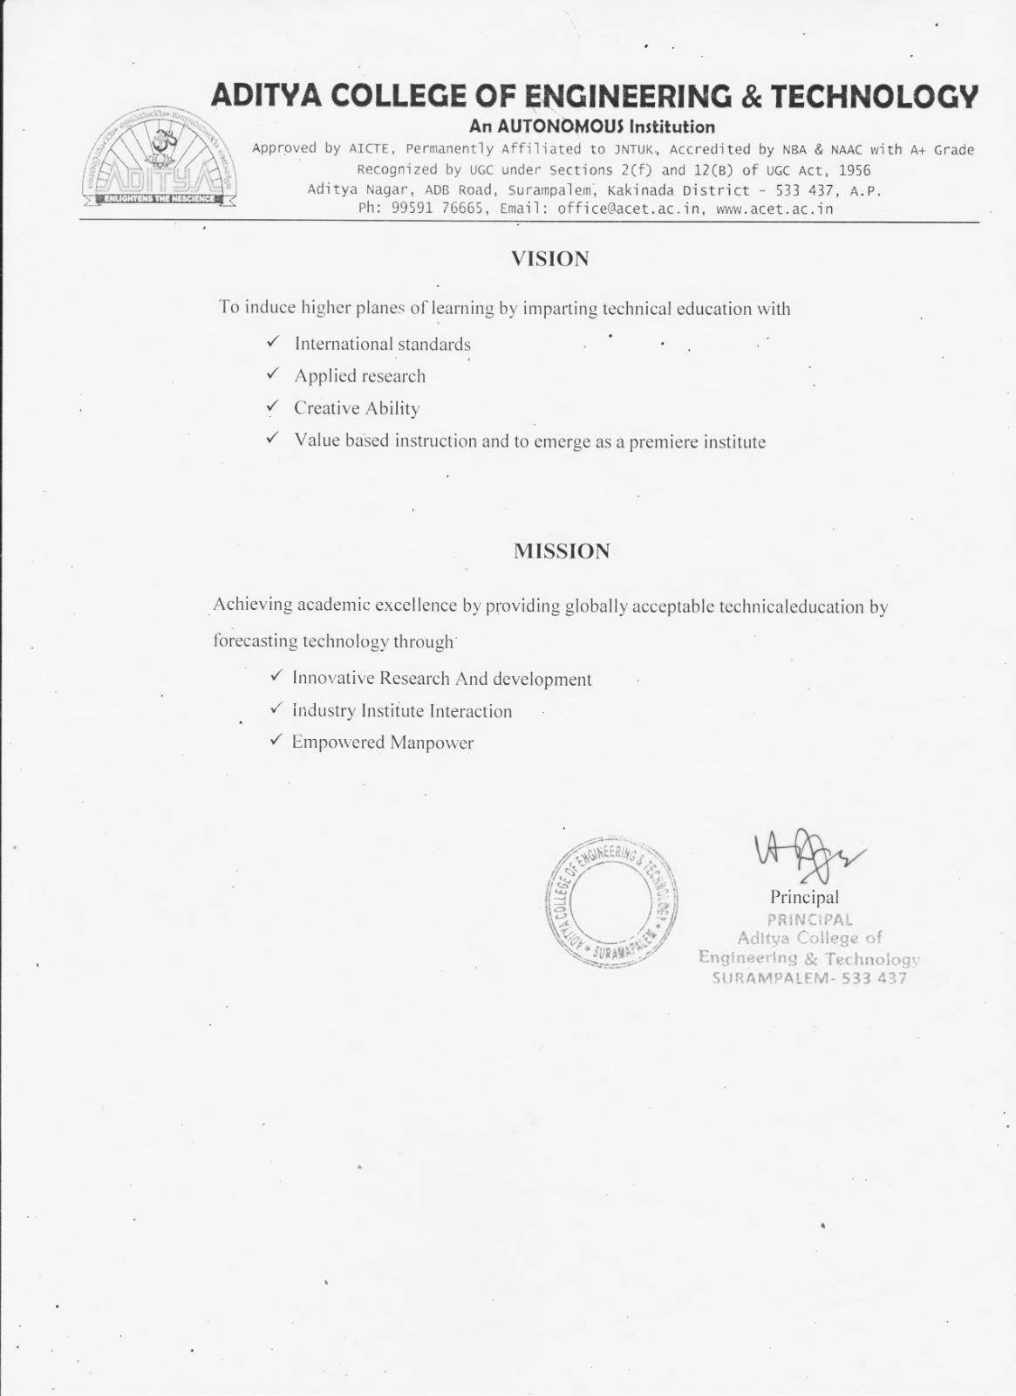

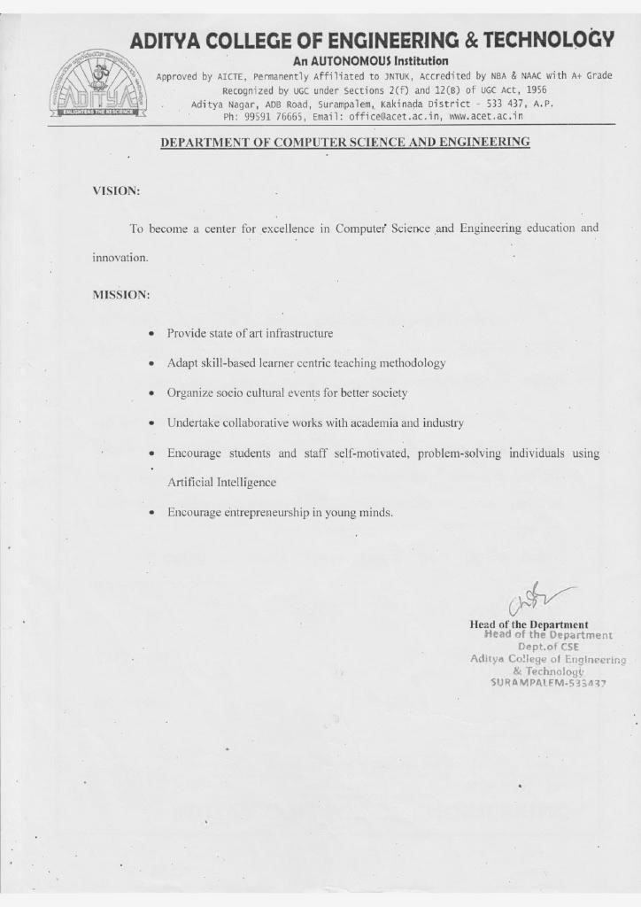

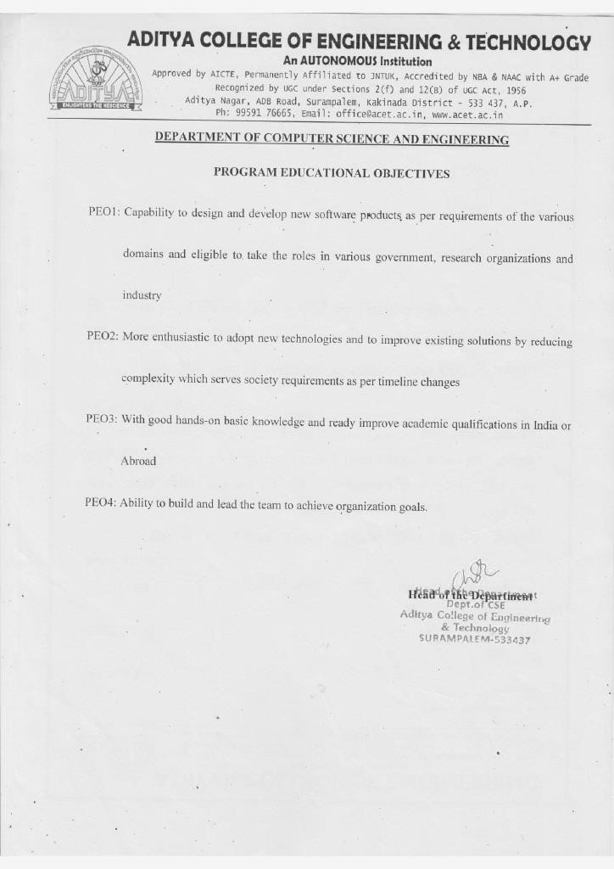

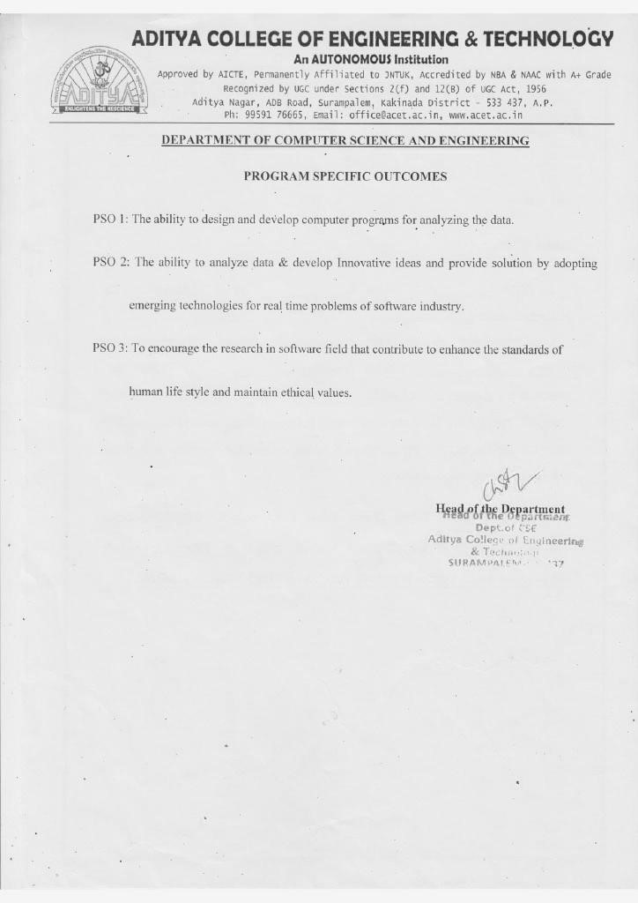

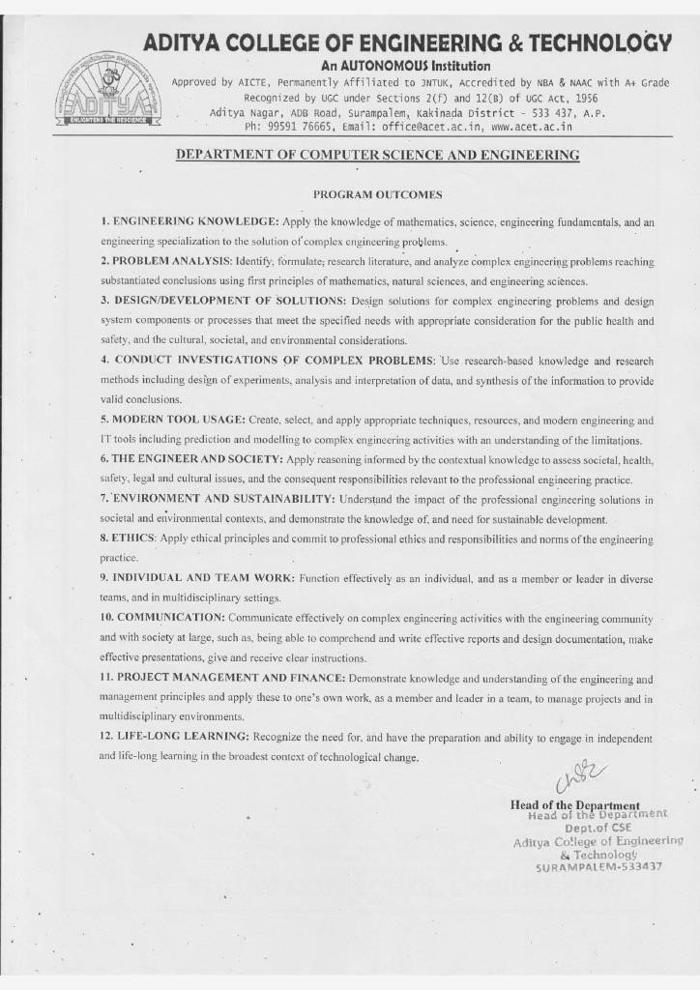

## ADITYA COLLEGE OF ENGINEERING & TECHNOLOGY

Approved by AICTE, New Delhi & Affiliated to JNTUK, Kakinada Accredited by NAAC

(A+) and NBA

**DEPARTMENT OF COMPUTER SCIENCE AND ENGINEERING**

## CERTIFICATE



### This is to certify that the Community Service Project work entitled, “ANTI

PLASTIC AWARENESS”, is a bonafied work carried out by GANTI PETERSON (23P31A0572) ,BORA VENKAT PRAVEEN REDDY (23P31A0585), BASWA BHAVANA SHANMUKHI (23P31A0596), ANGULURI BABITHA ESTHER RANI (23P31A05A1), GOGU VENNELA (23P31A05A5), JORUNGU GOPAL RAO (23P31A05A6), NALLA SIVANANDU (23P31A05C0), VOLETI PAVAN TEJA (23P31A05C4), DUGGUDURTHI

SAI RAJANI (24P35A0513), in partial fulfilment of the requirements for the award of the degree of BACHELOR OF TECHNOLOGY in COMPUTER SCIENCE AND

ENGINEERING from Aditya College of Engineering and Technology, Surampalem, during the academic year 2023-2024.

This project work has not been submitted in full or part to any other University or Educational Institute for the award of any Degree or Diploma.

**PROJECT SUPERVISOR HEAD OF THE DEPARTMENT**

Mr. JAGATHA S NARENDRA KUMAR,

### Sr. Assistant Professor

M. Tech (PhD).

EXTERNAL EXAMINER

## Students Declaration

We, that GANTI PETERSON (23P31A0572), BORA VENKAT PRAVEEN REDDY (23P31A0585), BASWA BHAVANA SHANMUKHI (23P31A0596),ANGULURI BABITHA ESTHER RANI (23P31A05A1), GOGU VENNELA (23P31A05A5), JORUNGU GOPAL RAO (23P31A05A6), NALLA SIVANANDU (23P31A05C0), VOLETI PAVAN TEJA (23P31A05C4), DUGGUDURTHI SAI RAJANI (24P35A0513) of the Department of COMPUTER SCIENCE ENGINEERING, Aditya College of Engineering and Technology do Hereby declare that, We have completed the mandatory community service project from 21-05-2024 To 05-06-2024 in Chinna Swami Nagar under the Faculty Guideship of Mr. Jagatha S Narendra Kumar sir , Department of Computer Science Engineering in College Aditya College Of Engineering and Technology.

### (student signature and date)

GANTI PETERSON (23P31A0572)

BORA VENKAT PRAVEEN REDDY (23P31A0585)

#### Endorsements

BASWA BHAVANA SHANMUKHI (23P31A0596)

ANGULURI BABITHA ESTHER RANI (23P31A05A1)

Faculty Guide GOGU VENNELA (23P31A05A5)

JORUNGU GOPAL RAO (23P31A05A6)

NALLA SIVANANDU (23P31A05C0)

Head of the department VOLETI PAVAN TEJA (23P31A05C4)

DUGGUDURTHI SAI RAJANI (24P35A0513)

## Certificate from Official of the Community

### This is to certify that GANTI PETERSON (23P31A0572), BORA VENKAT

PRAVEEN REDDY (23P31A0585), BASWA BHAVANA SHANMUKHI (23P31A0596), ANGULURI BABITHA ESTHER RANI (23P31A05A1), GOGU VENNELA (23P31A05A5), JORUNGU GOPAL RAO (23P31A05A6), NALLA SIVANANDU (23P31A05C0), VOLETI PAVAN TEJA (23P31A05C4), DUGGUDURTHI SAI RAJANI (24P35A0513) of Aditya College of Engineering and Technology underwent Community Service in Chinna swamy Nagar from 21-May-2024 to 05-June-2024. The overall performance of the Community service Volunteer during his / her community service is found to be ____________ (Satisfactory /Good).

**ACKNOWLEDGEMENT**

We feel elated to thank Principal, Dr A RAMESH, Aditya College of Engineering and Technology for his cooperation in the completion of our project and throughout our course.

We feel elated to thank Dr. PSVVS RAVI KUMAR Dean (Academics) of Aditya College of Engineering and Technology for his cooperation in the completion of our project work.

We wish to express our sincere thanks to Dr. Ch.SVVSN MURTHY Head of the Department of CSE, for his valuable guidance given to us throughout the period of the project work.

It is with immense pleasure that we would like to express our indebted gratitude to my project supervisor, Mr. J S NARENDRA KUMAR MTech (PhD), who has guided us a lot and encouraged us in every step of project work, his valuable moral support and guidance has been helpful in successful completion of this Project.

We wish to express our sincere thanks to all faculty members, and lab programmers for their valuable guidance given to us throughout the period of the project.

We avail this opportunity to express our deep sense and heart full thanks to the Management of Aditya College of Engineering & Technology for providing a great support for us by arranging the trainees, and facilities needed to complete our project and for giving us the opportunity for doing this work.

### STUDENT NAME

#### GANTI PETERSON (23P31A0572)

#### BORA VENKAT PRAVEEN REDDY (23P31A0585)

#### BASWA BHAVANA SHANMUKHI (23P31A0596)

#### ANGULURI BABITHA ESTHER RANI (23P31A05A1)

#### GOGU VENNELA (23P31A05A5)

#### JORUNGU GOPAL RAO (23P31A05A6)

#### NALLA SIVANANDU (23P31A05C0)

VOLETI PAVAN TEJA (23P31A05C4)

DUGGUDURTHI SAI RAJANI (24P35A0513)

## ABSTRACT

Plastic pollution poses a severe threat to the environment, public health, and sustainable development. This abstract explores the importance of anti-plastic awareness campaigns and strategies in mitigating the adverse effects of plastic use and disposal. It highlights the critical areas impacted by plastic pollution, including ecosystems, human health, and economic sectors, while addressing the challenges of reducing plastic dependency. Effective anti-plastic initiatives, such as promoting alternatives, implementing waste management solutions, and fostering behavioral change, are emphasized as key steps toward a sustainable future.

**Importance of Anti-Plastic Awareness:** Raising awareness about the detrimental effects of plastic and promoting alternatives is crucial in several areas, including:

* **Public Health:** Reducing the use of single-use plastics can prevent microplastic contamination in food and water, improving health outcomes.
* **Ecosystem Health:** Limiting plastic waste safeguards terrestrial and aquatic ecosystems from degradation and supports biodiversity.
* **Sustainable Industry:** Encouraging industries to adopt biodegradable materials and sustainable packaging options can minimize Environmental harm.
* **Waste management:** Public education on proper segregation and recycling can lead to more effective waste management practices.

**Challenges in Addressing Plastic Pollution:** Despite growing awareness, several challenges persist in reducing plastic use:

* **Over Dependence on Plastics:** Widespread reliance on affordable and convenient plastic products complicates efforts to minimize usage.
* **Improper Disposal:** Ineffective waste management systems result in littering, landfill overflow, and marine pollution.
* **Lack of Alternatives:** Limited availability and high cost of eco-friendly materials hinder their widespread adoption.
* **Public Perception:** Behavorial inertia and lack of awareness delay the shift toward sustainable practices.
* **Environmental Degradation:** Improper disposal of plastics harms marine and terrestrial ecosystems, endangers wildlife, and disrupts natural processes.

## CONTENTS

**CHAPTER PAGE**

**No.**

**ABSTRACT**  **xii-xiii**

**LIST OF FIGURES**  **xvi**

1. **EXECUTIVE SUMMARY**  **1-2** 
   1. Brief description of the Community 1
   2. Summary of all the activities 1
   3. Learning objectives 1-2
   4. Project outcomes 2

1. **OVERVIEW OF THE COMMUNITY 3-4** 
   1. Historical profile of the community / habitation  **3**
   2. Brief note on Socio-Economic conditions of the Community 3-4
2. **COMMUNITY SERVICE PART 5-10** 
   1. Activities undertaken in the Community 5-6
      1. Activity log for first week 7
      2. Weekly Report of Week-1 8
      3. Activity log for second week 9
      4. Weekly Report of Week-2 10
3. **OUTCOMES DESCRIPTION 11-17** 
   1. Details of the Socio-Economic Survey of the 11

Village/Habitation

* 1. Questionnaire prepared for the survey 11
  2. Problems identified in the community 11-12
  3. Short-term and Long-term action plans for possible solutions
  4. Community awareness programs conducted 13-14
  5. Report of the mini-project work done 14-15

15-17

1. **RECOMMENDATIONS AND CONCLUSIONS**   **18-19**

**OF THE MINI PROJECT**

1. **POWER POINT PRESENTATION SLIDES 20-26**
2. **STUDENT SELF-EVALUATION FOR THE CSP 27-35**
3. **EVALUATION BY THE PERSON IN-CHARGE IN THE 36-44**

**COMMUNITY HABITATION**

1. **PHOTOS & VIDEO LINKS 45-47**
2. **INTERNAL ASSESSMENT STATEMENT 48-56**

## LIST OF FIGURES

**S.No. NAME OF THE FIGURES PAGE**

**No.**

1. 2.1.1 Swamy nagar Village 3
2. 3.1 Grama Sachivalayam 6

## CHAPTER 1: EXECUTIVE SUMMARY

**1.1 BRIEF DESCRIPTION ON COMMUNITY:**

We chose the village of Swamy Nagar (pincode 533006) for our community service project. It is a small village in Kakinada Mandal, East Godavari District, Andhra Pradesh State, India, covering an area of 550 Hectares and housing 6952 people in 1667 houses. The Indrapalem Panchayathis in charge of it. The postal headquarters is in Kakinada Town, and it is 7.4 kilometers from Indrapalem to Kakinada. We discovered that the majority of people there are having issues with the plastic that is disposing everywhere in the village.

Therefore, as there is a need to make an awareness on Anti-Plastic to improvetheir quality of life, we have chosen this area.

**1.2 SUMMARY OF ACTIVITIES DONE:**

* Identifying a village that is ideal for our project as the site.
* I saw the panchayat secretary and, with his consent, told him about our village initiative.
* Began the survey by creating a questionnaire designed to gather data from households about their plastic usage, disposal practices, and awareness of plastic waste management.
* Based on that data, the people in the village are using plastic in high range, and we also learned how well-informed they were about plastic usage.
* Additionally, we discovered a few causes for the high range of plastic usage they are experiencing and the issues that the households are facing.
* We have discovered some preventive solutions to theirs issues.
* Held meetings and an awareness campaign in the community to aware the locals about plastic.
* Additionally, we ran an awareness campaign at Z.P.H school in an effort to educate the younger generation students about the causes of using plastic in an over range.

**1.3 LEARNING OBJECTIVES:**

* Educate the community on the harmful effects of plastic pollution on the environment and human health.
* Understand the lifecycle of plastics and their non-biodegradable nature.
* Explore and promote alternatives to single-use plastics, such as reusable or biodegradable materials.
* Learn about waste segregation and effective recycling methods.
* Analyze how excessive plastic usage impacts ecosystems, including water bodies and soil quality.
* Develop problem-solving skills to identify and reduce plastic usage in daily life.
* Study the production, consumption, and waste trends of plastics globally and locally to identify key problem areas.

**1.4 PROJECT OUTCOMES:**

* **Reduction in Plastic Use:**

Decrease in single-use plastic consumption in the target community.

* **Increased Awareness:**

Better understanding among the community about plastic pollution and its alternatives.

* **Improved Waste Management:**

Implementation of waste segregation practices and recycling systems.

* **Cleaner Environment:**

Reduction in plastic litter in local areas, benefiting ecosystems and biodiversity.

* **Behavioral Change:**

Adoption of sustainable practices like using cloth bags, avoiding plastic straws, and reusing materials.

* **Community Involvement:**

Active participation in clean-up drives, workshops, and awareness programs.

* **Economic Benefits:**

Support for local businesses that promote sustainable and plastic-free products.

## CHAPTER 2: OVERVIEW OF THE COMMUNITY

**2.1 ABOUT SWAMY NAGAR**

Swamy Nagar, located in Indrapalem, Kakinada, is a small but developing area in Andhra Pradesh. It is situated approximately 5 km from Kakinada city center. The area is wellconnected to nearby towns and cities.Swamy Nagar village Pin code is 533006.

Swamy Nagar Village Total population is around 6,000 and number of houses are approximately 1,500. Female Population is 48.0%. Village literacy rate is 61.0% and the Female Literacy rate 30.0%. Gadala Total area is 550 hectares.

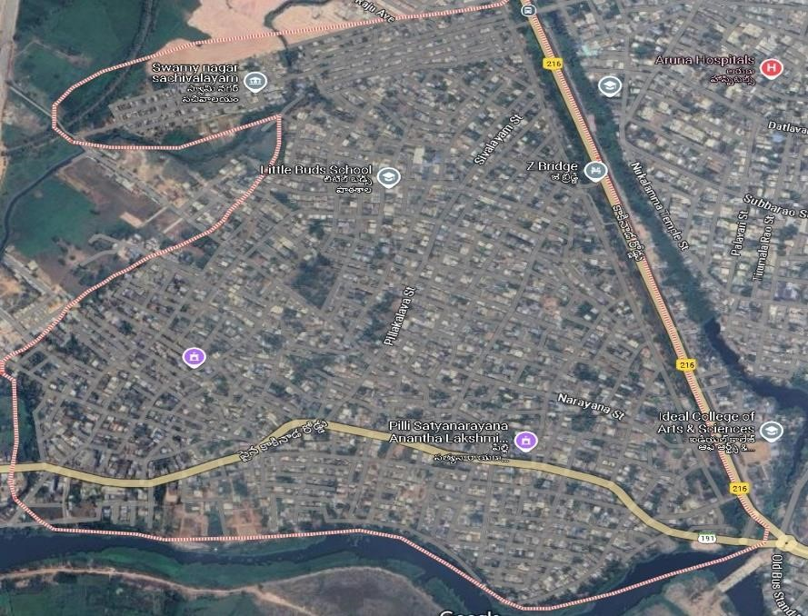

**Fig 1: 2.1.1 Swamy Nagar Village**

**2.2 Plastic waste management in Swamy Nagar irregular waste collection:**

In Swamy Nagar, the collection of plastic waste is inconsistent, leading to dissatisfaction among residents. Municipal workers fail to collect plastic waste regularly, resulting in its accumulation. People are forced to store plastic waste at home in bags, which are often not recycled or properly disposed of. Residents have suggested implementing a systematic and regular collection schedule to resolve this issue.

**Lack of waste segregation practices:**

The residents of Swamy Nagar lack awareness about the importance of segregating plastic waste from other types of waste. Due to the absence of proper waste bins and guidance, all waste is disposed of as a single unit. The concept of **Reduce, Reuse, Recycle** is unfamiliar to many, which further prevents the community from adopting sustainable practices. Introducing educational initiatives could help residents understand the benefits of segregation and recycling.

**Drainage issues caused by plastic waste:**

Plastic waste has a significant impact on the drainage systems in Swamy Nagar. Clogged drains due to improper disposal of plastics worsen during the rainy season, causing flooding and stagnant water, which attract pests and pose health risks. The lack of regular cleaning and maintenance of drains has exacerbated the problem. Many residents have called for immediate attention to this issue through consistent maintenance and community-driven cleanliness efforts.

## CHAPTER 3: COMMUNITY SERVICE PART

**3.1 Activities undertaken in the Community**

Our survey revealed that the majority of people do not practice appropriate waste management, particularly regarding the use and disposal of plastic. Additionally, we discovered that several environmental and health issues are affecting those who heavily rely on single-use plastics for their daily needs.

Some people are aware of eco-friendly alternatives but are still Considering the benefits and advantages of reducing plastic usage. However, the impact of plastic pollution on the environment and health is already significant and continues to grow.

We visited a few homes as part of our survey, spoke with the residents, and collected data on the types of plastic items they use, their disposal Practices, and the alternatives they might consider. According to this data, some people are hesitant to reduce plastic usage due to factors like the cost of eco-friendly alternatives, lack of awareness about the consequences, and convenience associated with plastic items.

According to the community data, consumers primarily rely on plastic for a number of reasons, including its affordability, availability, and ease of use. However, improper disposal has led to issues such as pollution of water bodies, soil degradation, and health problems caused by microplastics entering the food chain.

We have therefore concluded that many people are unaware of the long-term consequences of plastic pollution. After considering the viewpoints of local households and community members, we have worked to raise awareness by meeting with some households, listening to their concerns, and understanding their perspectives.

We have explained the advantages and importance of reducing plastic usage, provided general information about the harmful effects of plastic waste, and highlighted the environmental and health problems caused by plastic pollution. Additionally, we have conducted awareness programs to educate individuals about the importance of eco-friendly alternatives, proper disposal methods, and the collective effort required to mitigate the damage caused by plastic.

These sessions have aimed to inspire behavioural change and promote sustainable practices within the community.

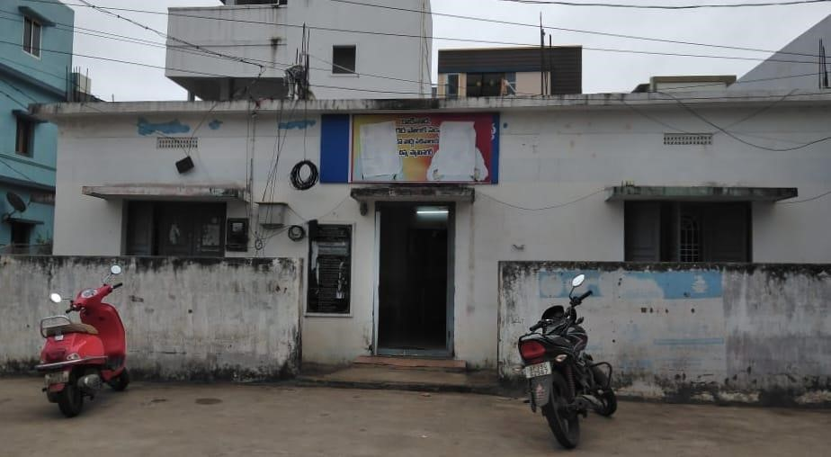

**Fig 1 : 3.1 Grama Sachivalayam**

## 3.1.1 ACTIVITY LOG FOR FIRST WEEK

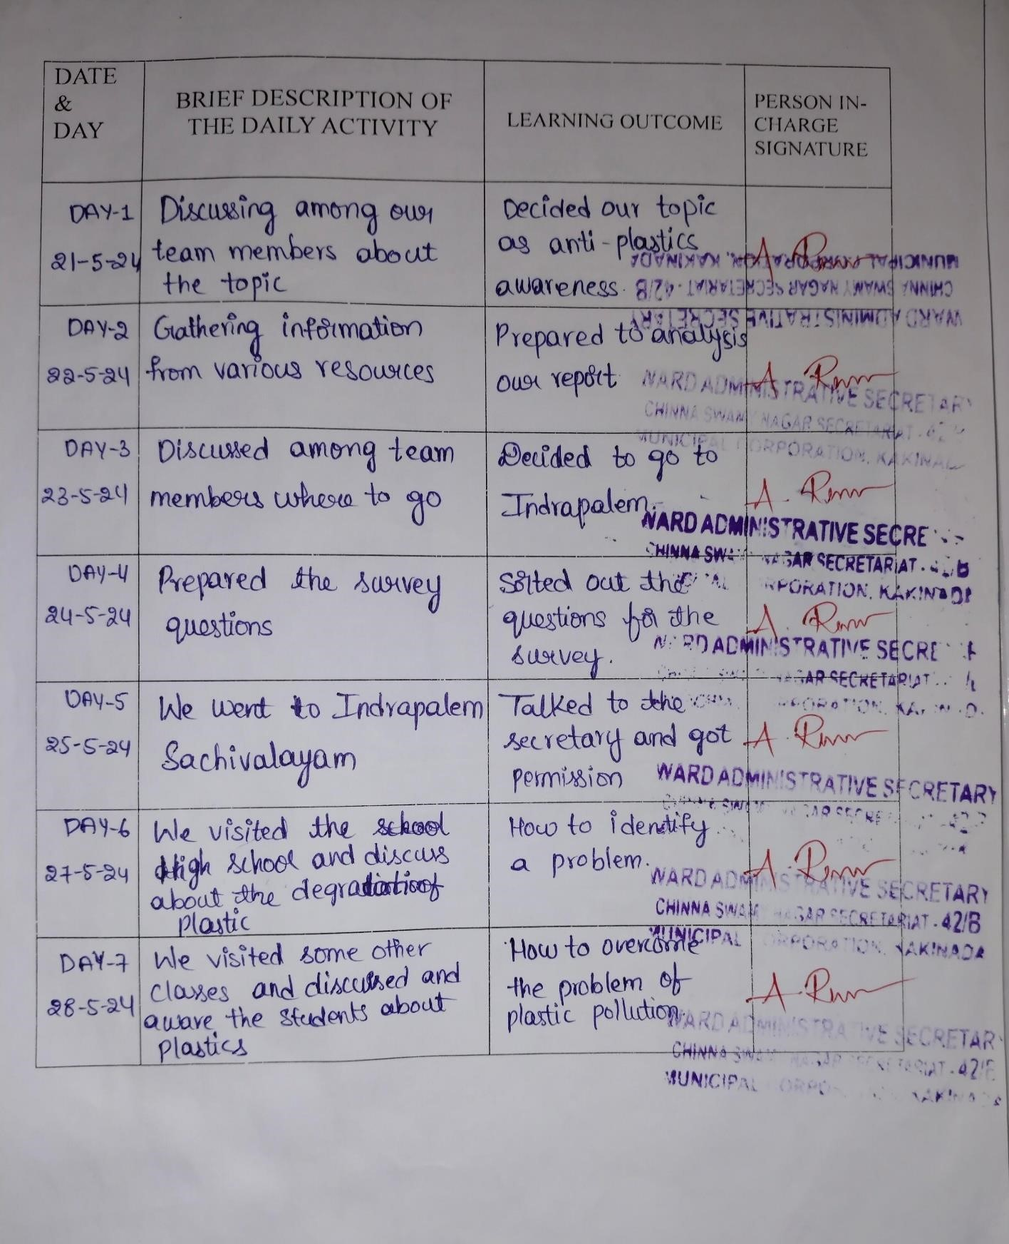

## 3.1.2 WEEKLY REPORT

WEEK – 1 (From Dt:21-05-2024 to Dt: 28-05-2024)

**Objective of the Activity Done:**

**Detailed Report:** As part of our community service project, we explored several topics of social and environmental importance, such as air pollution, water pollution, sericulture, online scams, organic farming, yoga awareness, and waste management. After thoughtful discussion and analysis, we unanimously decided to focus on the topic of "Awareness on Anti-Plastics". This decision was driven by the realization that plastic pollution is one of the most critical environmental challenges today, impacting ecosystems, human health, and wildlife alike.

Our team began by gathering detailed information on the topic from various sources, including online platforms, environmental journals, and expert opinions. We studied the impacts of plastic usage, improper disposal practices, and the benefits of adopting sustainable alternatives. Based on our research, we identified **Indrapalem** as the target location for our awareness program due to its need for education on plastic management and the potential for significant positive impact through increased awareness.

To prepare for the campaign, we drafted a questionnaire to understand the community's practices and challenges regarding plastic pollution. We also created educational materials, such as posters and leaflets, to effectively communicate our message.

Before starting, we obtained permission from the local Sachivalayam, where the Secretary appreciated our initiative and guided us on engaging with the villagers.

Through activities and discussions, we inspired them to contribute to a sustainable future.

## 3.1.3 ACTIVITY LOG FOR SECOND WEEK

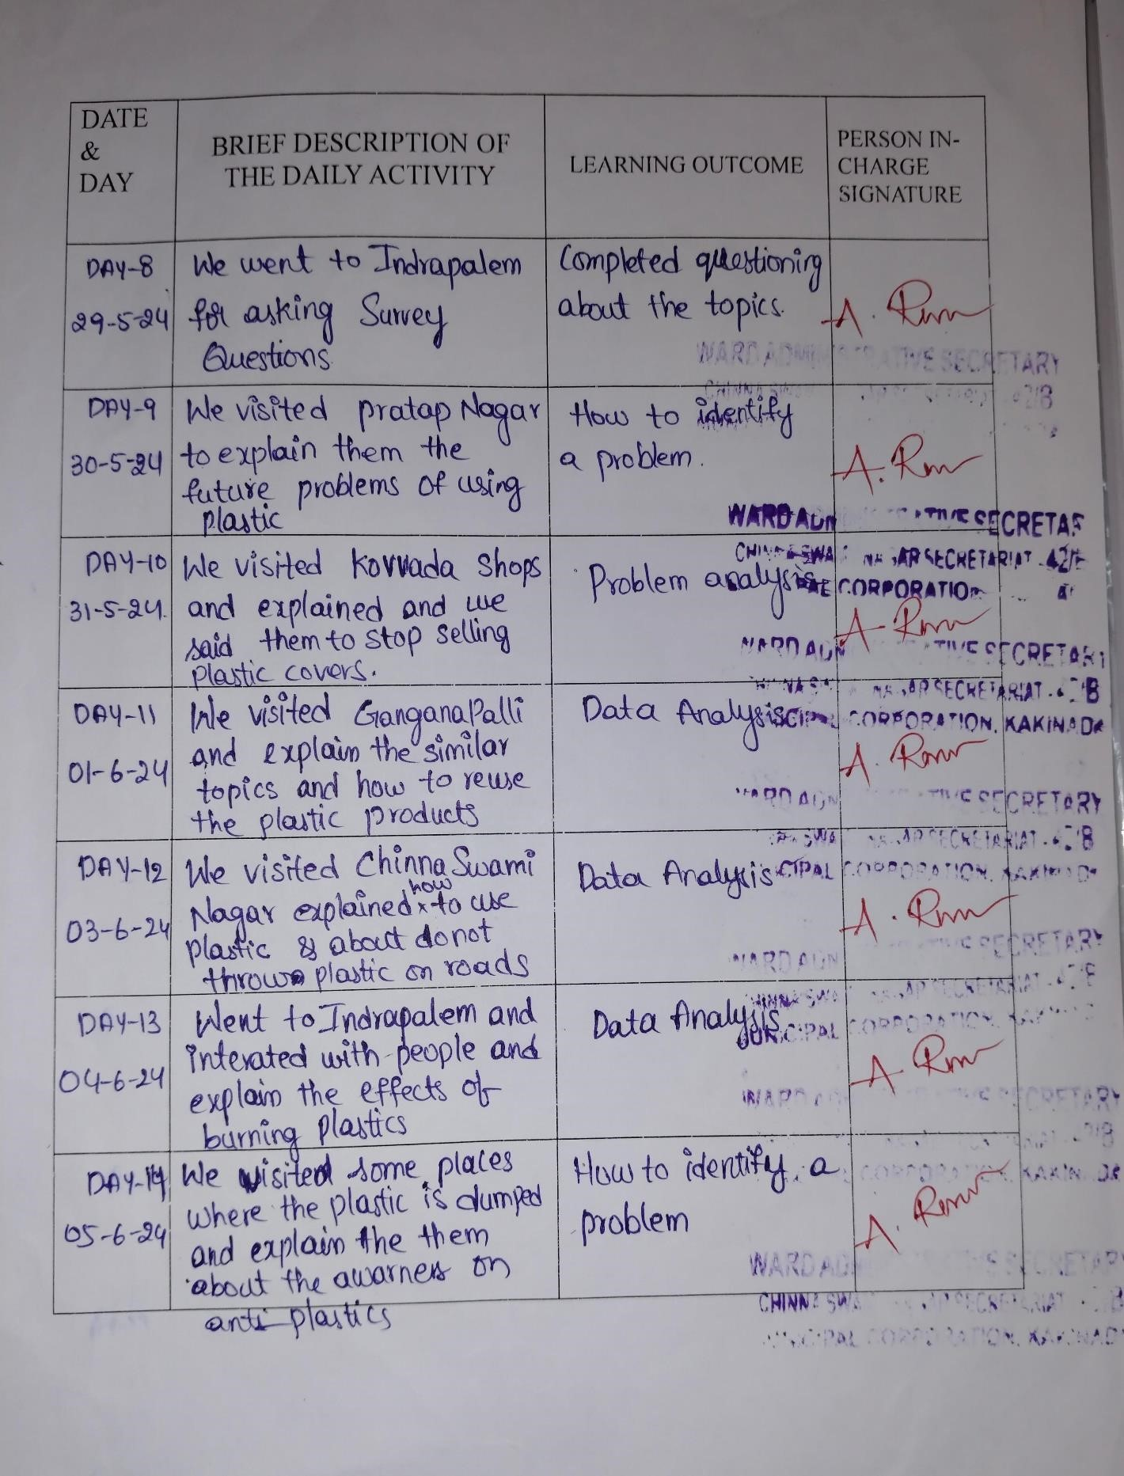

## 3.1.4 WEEKLY REPORT

WEEK – 2 (From Dt:29-05-2024 to Dt: 05-06-2024)

**Objective of the Activity Done:**

**Detailed Report:**

As part of our campaign, we expanded our efforts to reach not just Indrapalem but also its subvillages, including Pratap Nagar, Kovvada, Chinna Swamy Nagar, and Gangana Palli. These areas were identified as key locations where awareness about plastic pollution and sustainable alternatives was crucial. Our aim was to educate and engage with the residents of these villages to inspire collective action against plastic waste.

We began our campaign with household visits, engaging residents in discussions about the harmful effects of plastics on the environment, including soil contamination, water pollution, and harm to wildlife. We also highlighted the health risks of microplastics entering the food chain.

To make the sessions impactful, we suggested practical solutions like using reusable cloth bags, biodegradable products, and proper waste segregation. The villagers responded positively, showing interest in eco-friendly practices and sharing concerns like inadequate waste management and the affordability of alternatives.

In conclusion, the activity successfully spread awareness, inspired behavioral change, and reinforced the importance of grassroots action. The support from the community and the Sachivalayam motivated us to expand such initiatives to other areas, contributing to a cleaner, greener future.

## CHAPTER4: OUTCOMES DESCRIPTION

**4.1 Details of the Socio-Economic Survey of the Village/Habitation**

The topic for the Socio-Economic Survey that we have chosen is “ANTI-PLASTIC AWARENESS”. Plastic waste management is vital for ensuring a clean environment, protecting public health, and safeguarding natural resources. To address the growing issue of plastic pollution, we chose Swamy Nagar village as the focus of our survey.

We began by meeting with higher officials at the Sachivalayam in Swamy Nagar. We explained the objective of our survey, including our plans to understand the community's current practices and challenges regarding plastic waste. After obtaining the necessary permissions, we started our survey with enthusiasm and determination.

Our team visited most number of households in Swamy Nagar to engage directly with the residents and gather valuable information about their awareness and practices related to plastic waste management.

Among those details, we can identify whether residents are experiencing any health or environmental issues due to improper plastic disposal. So, to collect those details we have interacted with the village people by asking some questions that we prepared.

**4.2 Questionnaire prepared for the survey**

1. Do you know what plastic pollution is?
2. Do you know the harm caused by the plastic?
3. Plastic is being collected in your village?
4. Do you ever burn plastic?
5. Do you recycle plastic?
6. Which plastic products do you use most often?
7. Are there separate bins for throwing plastic in your village?
8. How often do you buy plastic equipment?
9. Which of the following ideas would you be more helpful for reducing pollution?
10. Can you give any suggestions to save your village from plastic pollution?

**4.3 Problems identified in the community:**

1. Frequent Use of Plastic
2. Improper Disposal of Plastic Waste
3. No Dustbins for Plastic Disposal 4 Lack of Awareness on Recycling
4. Air Pollution from Burning Plastic
5. Drainage Blockages due to Plastic Waste
6. Water Pollution from Plastic Waste

1. **Frequent Use of Plastic:**

Plastic is widely used in the village for various purposes, leading to an increase in plastic waste.

1. **Improper Disposal of Plastic Waste:**

Plastic waste is thrown everywhere due to the lack of designated dustbins or proper waste disposal systems, contributing to littering and environmental degradation.

1. **No Dustbins for Plastic Disposal:**

The absence of dustbins or appropriate disposal facilities means that plastic waste is not collected or managed effectively.

1. **Lack of Awareness on Recycling:**

There is a significant lack of awareness and education about the importance of recycling and proper disposal methods, which contributes to the improper handling of plastic waste.

1. **Air Pollution from Burning Plastic:**

The practice of burning plastic waste is common, leading to the release of toxic fumes and contributing to air pollution, which poses health risks to the community.

1. **Drainage Blockages due to Plastic Waste:**

Plastic waste often ends up in the drainage systems, causing blockages that can lead to flooding and other sanitation issues.

1. **Water Pollution from Plastic Waste:**

Plastic waste is frequently thrown into water bodies, leading to water pollution that harms aquatic life and contaminates drinking water sources.

**4.4. Short-Term and Long-term action plans for possible solutions:**

**Short-Term Actions:**

* Community Clean-Up Drives: Organize collective efforts to clean public spaces, such as parks, streets, and water bodies, to improve hygiene and aesthetics.
* Placement of Temporary Dustbins: Install dustbins in areas lacking waste disposal options, especially during events, to minimize littering.
* Conducting Awareness Campaigns: Educate the public about environmental issues, waste management, and sustainable practices through workshops, posters, or social media.
* Ban or Reduce Plastic Use: Advocate for reduced usage of single-use plastics by promoting alternatives like cloth bags, biodegradable packaging, and reusable containers.
* Prevent Burning of Plastics: Raise awareness about the toxic effects of burning plastics and implement measures to discourage the practice, including legal actions if necessary.
* Immediate Clearing of Blocked Drains: Ensure timely maintenance of drainage systems to prevent flooding and health hazards.
* Safe Disposal Initiatives: Develop and implement systems for the safe segregation, recycling, and disposal of different types of waste, including hazardous materials.

**Long-Term Actions:**

* Promote Reusable and Biodegradable Alternatives: Transition from single-use plastics to eco-friendly options like cloth bags, metal utensils, and biodegradable packaging to reduce waste at the source.
* Improve Waste Disposal Infrastructure: Install more bins, improve waste collection systems, and use technology to optimize disposal and prevent littering and pollution.
* Raise Awareness through Education: Conduct workshops, include environmental topics in school curriculums, and use social media to educate people about reducing and managing plastic waste.
* Enforce Regulations to Stop Plastic Burning: Implement strict laws against plastic burning and provide accessible alternatives like recycling facilities to protect health and the environment.
* Enhance Waste Management Systems: Maintain drainage systems, install trash traps in waterways, and use community-level waste segregation to prevent plastic pollution.
* Encourage Participation in Recycling Initiatives: Engage schools, families, and communities in recycling drives and reward proper waste segregation to build ecofriendly habits.
* Combine Policies, Public Education, and Innovation: Integrate regulations, awareness campaigns, and technological advancements to create a sustainable, long-term solution to plastic pollution.

**4.5 Community awareness programs conducted:**

1. Workshops on Plastic Alternatives
2. Health and Environmental Impact Campaigns
3. Demonstrations on Recycling and Upcycling
4. Public Information Sessions with Experts
5. School and Youth Programs
6. Door-to-Door Awareness Drives
7. Social Media and Community Engagement

**Highlight benefits:**

We have interacted with many people and discussed the challenges they face due to plastic pollution. Many shared concerns about littered plastics, clogged drains, and health issues caused by improper disposal of plastic waste. Through our programs, we created awareness among residents about the harmful effects of plastic and how to reduce its use.

We taught them simple actions like replacing single-use plastics with alternatives and segregating waste for recycling. These steps help minimize pollution and protect the environment**.**

Awareness programs equip residents with the knowledge to demand better waste management services and hold authorities accountable for addressing plastic pollution. By reducing plastic waste and discouraging harmful practices like burning plastic, residents are less exposed to toxins, resulting in fewer pollution-related health issues and lower medical expenses.

Preventive measures, like promoting recycling and reducing single-use plastics, reduce long-term costs associated with managing plastic waste and cleaning up the environment.

Educating people about the dangers of microplastics and plastic toxins helps lower the incidence of pollution-linked health problems, such as respiratory illnesses and hormonal disruptions. Knowledge of sustainable practices and waste reduction fosters resilience, enabling communities to manage future environmental challenges effectively.

These programs contribute to a healthier, more informed, and proactive community. Residents are now better equipped to reduce plastic use, advocate for sustainable practices, and create a future free from the adverse effects of plastic pollution

**4.6 Report of the mini-project work done in the related subject with respect to the habitation/village.**

This is a about the mini work that was done in the Indrapalem village. This project is about the Anti-Plastic Awareness. For this we choose a village and conduct awareness campaign with in the village. For this we have chosen the Indrapalem village which is located in the Kakinada mandal of East Godavari district in Andhra Pradesh, India. The pin code of Indrapalem is 533344. There are about 1667 houses in Indrapalem village. Indrapalem has a total population of 6952 people. Out of which male population is 3790 while female population is 3162.

**About anti-plastic awareness: Benefits for the Environment: -**

Anti-plastic awareness emphasizes the importance of reducing plastic usage and adopting sustainable alternatives to protect the environment. Plastics, particularly single-use plastics, contribute significantly to environmental degradation, harming ecosystems, wildlife, and human health. Addressing plastic pollution requires conscious efforts in management and education to foster eco-friendly practices.

Anti-plastic initiatives aim to reduce plastic production, encourage recycling, and promote the use of biodegradable materials. This approach benefits public health, supports economic growth, and mitigates the environmental impacts of plastic waste.

**Here are some key points:**

**Anti-plastic awareness provides many important benefits for:**

1. **Cleaner Environment:** Reducing plastic waste prevents littering and pollution, creating a healthier and cleaner environment for all.
2. **Protecting Wildlife:** Plastics that end up in ecosystems often harm animals through ingestion or entanglement; reducing plastic use helps protect biodiversity.
3. **Improved Public Health:** Decreasing plastic burning and microplastic exposure reduces health risks such as respiratory problems and other diseases.
4. **Sustainable Resource Use:** Encouraging recycling and alternative materials minimizes landfill waste and conserves natural resources.
5. **Reduced Climate Impact:** Lowering plastic production and incineration helps decrease greenhouse gas emissions, combating climate change.
6. **Preventing Water Pollution:** Proper management of plastic waste ensures it does not clog drains or pollute water bodies, safeguarding water quality.
7. **Community Awareness:** Education about the impacts of plastic pollution fosters community action and sustainable practices.
8. **Economic Opportunities:** The shift to biodegradable materials and recycling systems can create jobs and spur innovations in waste management.

**Why Anti-plastic awareness is important?**

Anti-plastic awareness is crucial for preserving environmental health and ensuring sustainable practices. Reducing plastic waste helps prevent pollution of land, water, and air. It also safeguards wildlife and promotes human health by minimizing exposure to toxic chemicals associated with plastics. Awareness campaigns empower communities to adopt alternatives, recycle more effectively, and reduce dependency on single-use plastics. This is key to building a sustainable future and addressing global environmental challenges.

**Steps we follow: -**

**1.Survey:** We collected data from households to understand plastic usage, disposal habits, and awareness levels.

**2.Identifying the problem:** Based on the survey data, we analysed and identified major issues related to plastic waste management in the community.

**3.Survey conduction in Swamy Nagar:** Formed a team to visit households in Swamy

Nagar. Designed a questionnaire to gather information about plastic usage, waste disposal, and recycling practices. Interacted with community members to understand their challenges and suggestions regarding plastic management**.**

## CHAPTER5: RECOMMENDATIONS AND CONCLUSIONS OF THE MINIPROJECT

1. The survey provided a valuable snapshot of the plastic usage, disposal practices, and challenges faced by the local village.
2. Upon completing our project, we raised awareness about "Anti Plastic"Practices and Sustainable Waste Management" and shared methods to reduce, reuse, and recycle plastic waste effectively.
3. Encouraged active participation of villagers in all stages of planning, implementing, and maintaining plastic waste management strategies.
4. Proposed the establishment of a Village Plastic Management Committee to oversee the management and decision-making processes related to plastic waste.
5. Organized regular community meetings to discuss plastic pollution issues, Share information on its environmental impact, and address concerns.
6. Suggested setting up designated collection points for plastic waste and conducting regular clean-up drives to reduce littering.
7. Promoted recycling by encouraging segregation of plastic waste from other waste materials at the household level.
8. Created awareness about the environmental hazards of burning plastic and dumping it into water bodies, encouraging alternative disposal methods.
9. Highlighted the importance of using reusable or biodegradable materials instead of single-use plastics.
10. Recommended the development of a long-term plastic waste management plan that aligns with sustainable practices and government regulations.
11. Advocated for the installation of proper disposal bins in public spaces and households to ensure organized waste management.
12. Conducted workshops on creating eco-friendly alternatives like cloth bags and natural packaging materials to reduce dependency on plastic.
13. Empowered villagers to take ownership of their plastic waste by educating them on the importance of proper waste management.
14. The anti-plastic awareness project has significantly improved community understanding and engagement in sustainable waste management.
15. By implementing these recommendations and continuing awareness programs, the village can serve as a model for other communities to tackle plastic pollution and achieve a cleaner, greener environment.
16. With sustained efforts, the village can protect its natural resources and ensure a healthier future for the coming generations.

## CHAPTER 6: POWER POINT PRESENTATION SLIDES

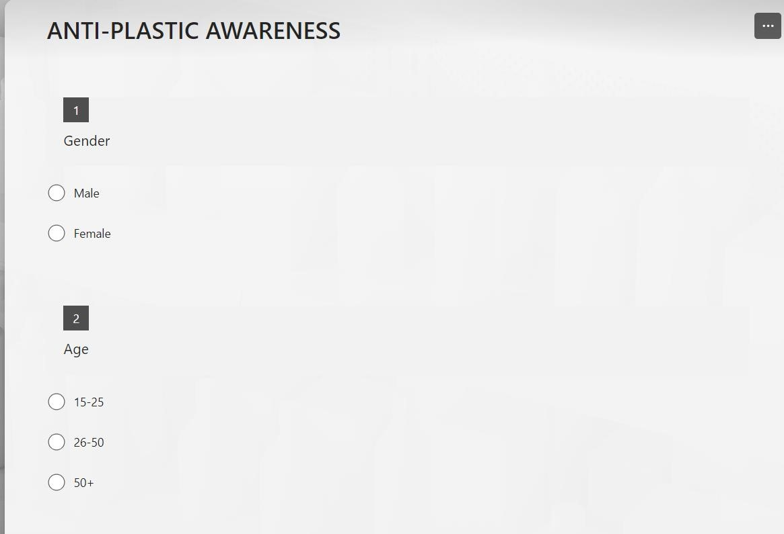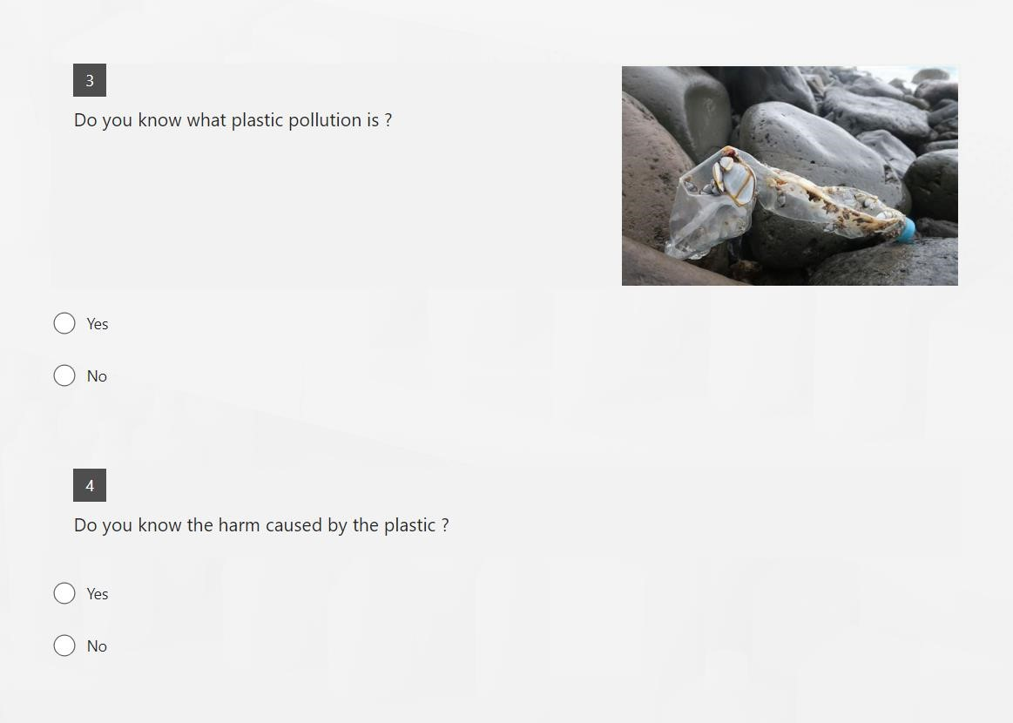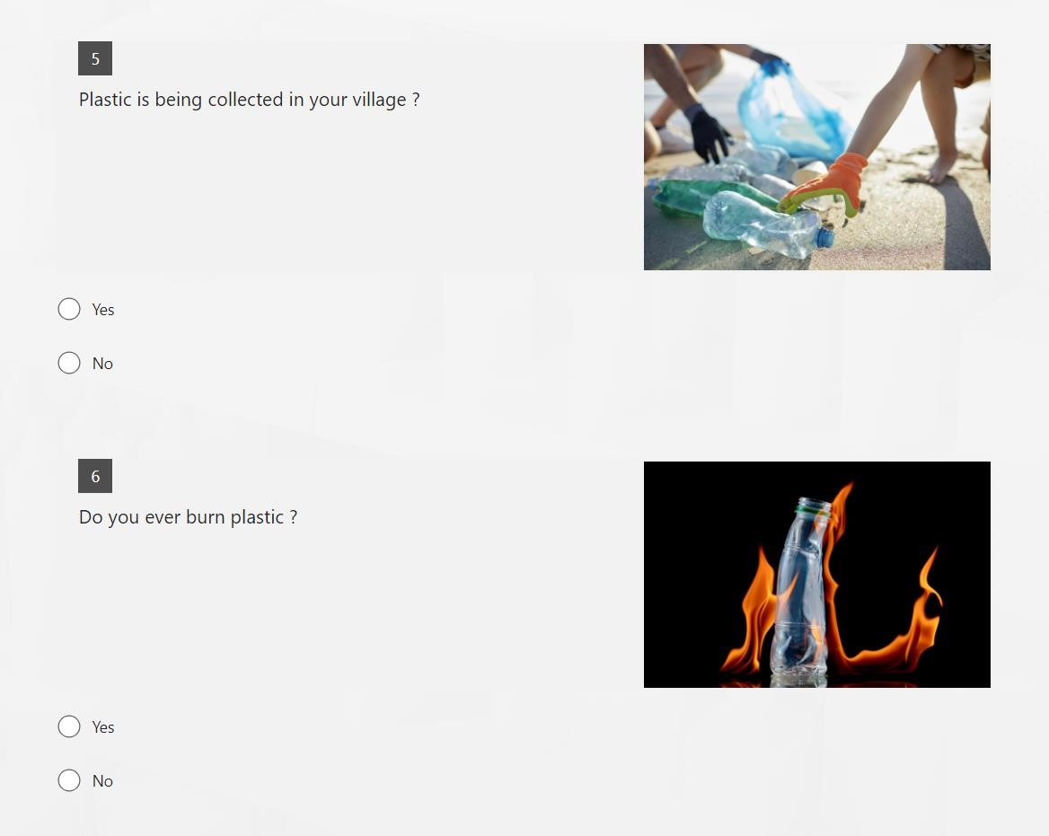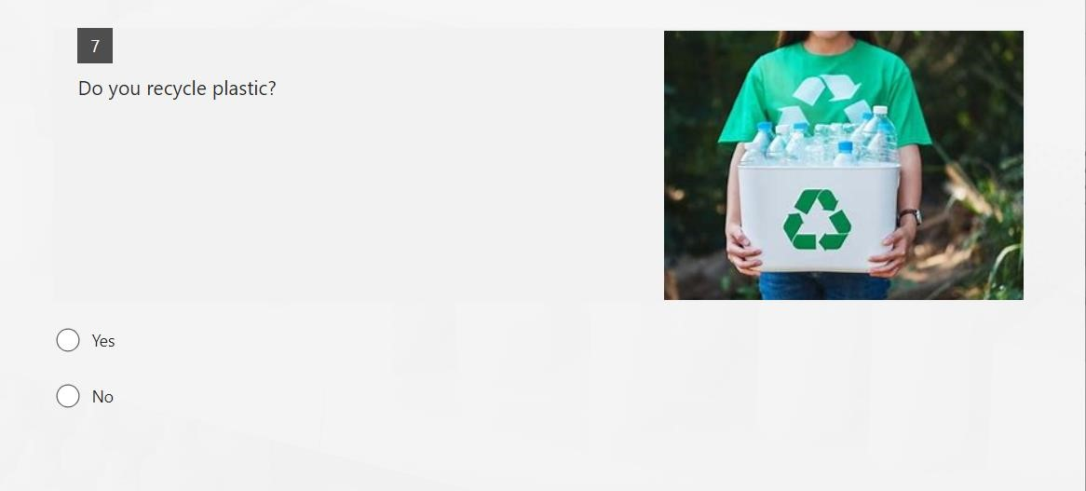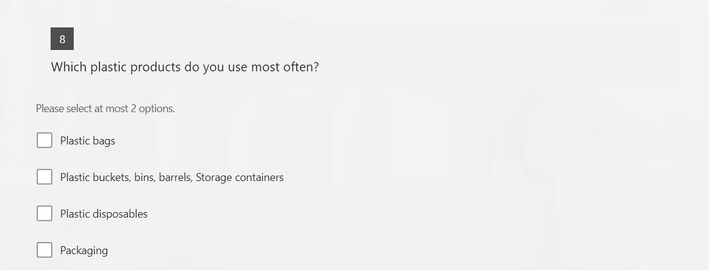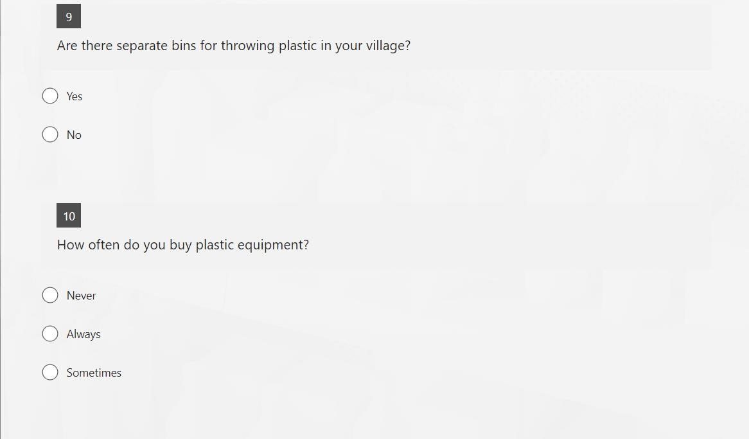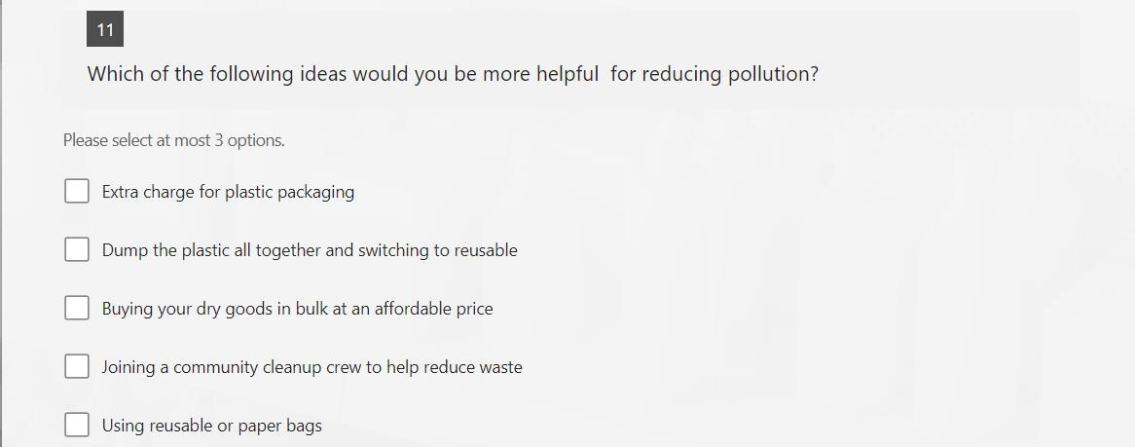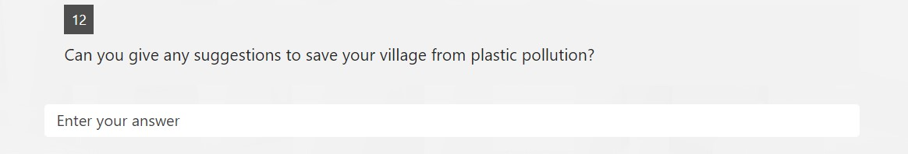

127 RESPONSES

Gender:

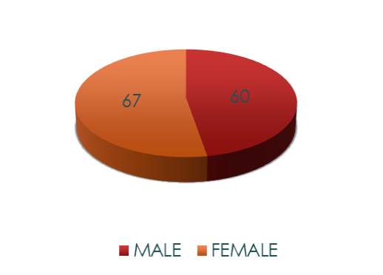

Age:

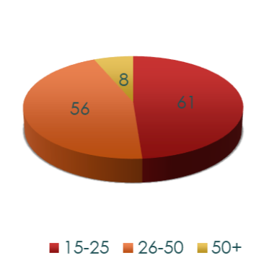

1. Do you know what plastic pollution is?

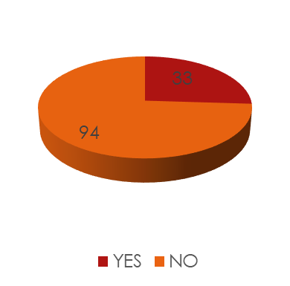

1. Do you know the harm caused by the plastic?

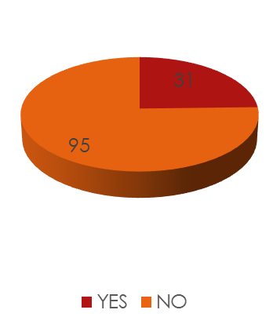

1. Plastic is being collected in your village?

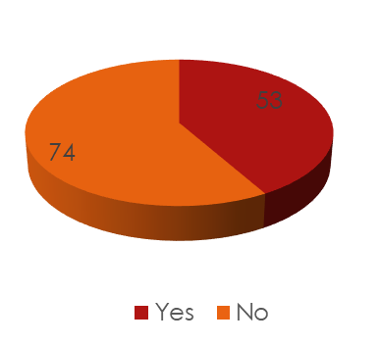

1. Do you ever burn plastic?

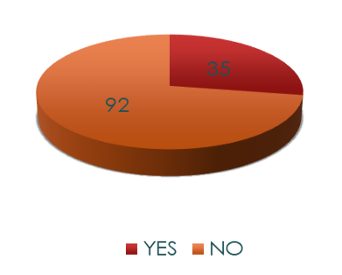

7.Do you recycle plastic?

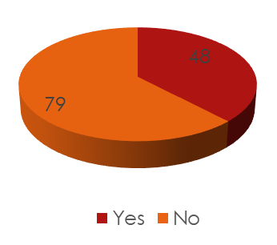

8.Which plastic products do you use most often?

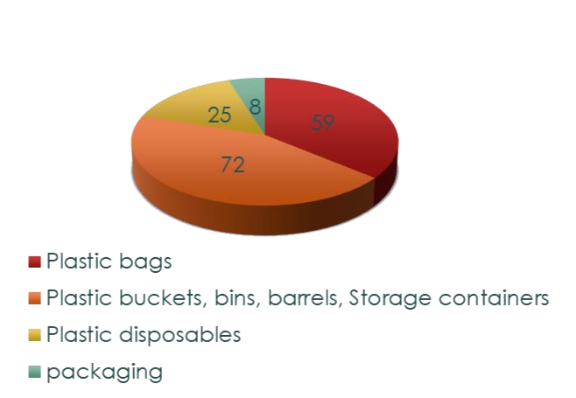

9.Are there separate bins for throwing plastic in your village?

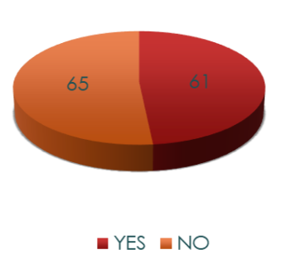

10.How often do you buy plastic equipment?

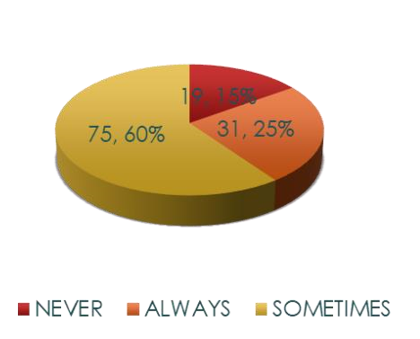

11.Which of the following ideas would you be more helpful for reducing pollution?

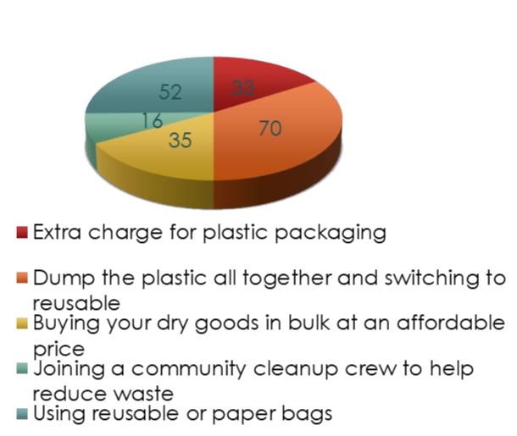

12. Can you give any suggestions to save your village from plastic pollution?

* Reduce use of plastics
* Separate dust bins for plastics
* Don’t use plastics
* Stop using plastics
* Don’t sell the plastic materials

**Student Name:** GANTI PETERSON

**Registration No:**23P31A0572

**Period of CSP:**21-05-2024 to 05-06-2024

**Date Of Evaluation:**

Please rate your performance in the following areas:

Rating Scale: Letter grade of CGPA calculation to be provided

|  |  |  |  |  |  |
| --- | --- | --- | --- | --- | --- |
| 1 Oral communication | 1 | 2 | 3 | 4 | 5 |
| 2 Written Communication | 1 | 2 | 3 | 4 | 5 |
| 3 Proactiveness | 1 | 2 | 3 | 4 | 5 |
| 4 Interaction ability with community | 1 | 2 | 3 | 4 | 5 |
| 5 Positive Attitude | 1 | 2 | 3 | 4 | 5 |
| 6 Self-confidence | 1 | 2 | 3 | 4 | 5 |
| 7 Ability to learn | 1 | 2 | 3 | 4 | 5 |
| 8 Work Plan and organization | 1 | 2 | 3 | 4 | 5 |
| 9 Professionalism | 1 | 2 | 3 | 4 | 5 |
| 10 Creativity | 1 | 2 | 3 | 4 | 5 |
| 11 Quality of work done | 1 | 2 | 3 | 4 | 5 |
| 12 Time Management | 1 | 2 | 3 | 4 | 5 |
| 13 Understanding the Community | 1 | 2 | 3 | 4 | 5 |
| 14 Achievement of Desired Outcomes | 1 | 2 | 3 | 4 | 5 |
| 15 OVERALL PERFORMANCE | 1 | 2 | 3 | 4 | 5 |

**Date:** **Signature of the student**

|  |
| --- |
| **Student Name:** BORA VENKAT PRAVEEN REDDY  **Registration No:**23P31A0585  **Period of CSP:** 21-05-2024 to 05-06-2024 **Date Of Evaluation:** |

Please rate your performance in the following areas:

Rating Scale: Letter grade of CGPA calculation to be provided

|  |  |  |  |  |  |
| --- | --- | --- | --- | --- | --- |
| 1 Oral communication | 1 | 2 | 3 | 4 | 5 |
| 2 Written Communication | 1 | 2 | 3 | 4 | 5 |
| 3 Proactiveness | 1 | 2 | 3 | 4 | 5 |
| 4 Interaction ability with community | 1 | 2 | 3 | 4 | 5 |
| 5 Positive Attitude | 1 | 2 | 3 | 4 | 5 |
| 6 Self-confidence | 1 | 2 | 3 | 4 | 5 |
| 7 Ability to learn | 1 | 2 | 3 | 4 | 5 |
| 8 Work Plan and organization | 1 | 2 | 3 | 4 | 5 |
| 9 Professionalism | 1 | 2 | 3 | 4 | 5 |
| 10 Creativity | 1 | 2 | 3 | 4 | 5 |
| 11 Quality of work done | 1 | 2 | 3 | 4 | 5 |
| 12 Time Management | 1 | 2 | 3 | 4 | 5 |
| 13 Understanding the Community | 1 | 2 | 3 | 4 | 5 |
| 14 Achievement of Desired Outcomes | 1 | 2 | 3 | 4 | 5 |
| 15 OVERALL PERFORMANCE | 1 | 2 | 3 | 4 | 5 |

Date: **Signature of the student**

**Student Name:** BASWA BHAVANA SHANMUKHI

**Registration No:**23P31A0596

**Period of CSP:** 21-05-2024 to 05-06-2024

**Date Of Evaluation:**

Please rate your performance in the following areas:

Rating Scale: Letter grade of CGPA calculation to be provided

|  |  |  |  |  |  |
| --- | --- | --- | --- | --- | --- |
| 1 Oral communication | 1 | 2 | 3 | 4 | 5 |
| 2 Written Communication | 1 | 2 | 3 | 4 | 5 |
| 3 Proactiveness | 1 | 2 | 3 | 4 | 5 |
| 4 Interaction ability with community | 1 | 2 | 3 | 4 | 5 |
| 5 Positive Attitude | 1 | 2 | 3 | 4 | 5 |
| 6 Self-confidence | 1 | 2 | 3 | 4 | 5 |
| 7 Ability to learn | 1 | 2 | 3 | 4 | 5 |
| 8 Work Plan and organization | 1 | 2 | 3 | 4 | 5 |
| 9 Professionalism | 1 | 2 | 3 | 4 | 5 |
| 10 Creativity | 1 | 2 | 3 | 4 | 5 |
| 11 Quality of work done | 1 | 2 | 3 | 4 | 5 |
| 12 Time Management | 1 | 2 | 3 | 4 | 5 |
| 13 Understanding the Community | 1 | 2 | 3 | 4 | 5 |
| 14 Achievement of Desired Outcomes | 1 | 2 | 3 | 4 | 5 |
| 15 OVERALL PERFORMANCE | 1 | 2 | 3 | 4 | 5 |

Date: **Signature of the student**

|  |
| --- |
| **Student Name:** ANGULURI BABITHA ESTHER RANI  **Registration No:**23P31A05A1  **Period of CSP:** 21-05-2024 to 05-06-2024 **Date Of Evaluation:** |

Please rate your performance in the following areas:

Rating Scale: Letter grade of CGPA calculation to be provided

|  |  |  |  |  |  |
| --- | --- | --- | --- | --- | --- |
| 1 Oral communication | 1 | 2 | 3 | 4 | 5 |
| 2 Written Communication | 1 | 2 | 3 | 4 | 5 |
| 3 Proactiveness | 1 | 2 | 3 | 4 | 5 |
| 4 Interaction ability with community | 1 | 2 | 3 | 4 | 5 |
| 5 Positive Attitude | 1 | 2 | 3 | 4 | 5 |
| 6 Self-confidence | 1 | 2 | 3 | 4 | 5 |
| 7 Ability to learn | 1 | 2 | 3 | 4 | 5 |
| 8 Work Plan and organization | 1 | 2 | 3 | 4 | 5 |
| 9 Professionalism | 1 | 2 | 3 | 4 | 5 |
| 10 Creativity | 1 | 2 | 3 | 4 | 5 |
| 11 Quality of work done | 1 | 2 | 3 | 4 | 5 |
| 12 Time Management | 1 | 2 | 3 | 4 | 5 |
| 13 Understanding the Community | 1 | 2 | 3 | 4 | 5 |
| 14 Achievement of Desired Outcomes | 1 | 2 | 3 | 4 | 5 |
| 15 OVERALL PERFORMANCE | 1 | 2 | 3 | 4 | 5 |

Date: **Signature of the student**

|  |
| --- |
| GOGU VENNELA  **Registration No:**23P31A05A5  **Period of CSP:** 21-05-2024 to 05-06-2024  **Date Of Evaluation:** |

Please rate your performance in the following areas:

Rating Scale: Letter grade of CGPA calculation to be provided

|  |  |  |  |  |  |
| --- | --- | --- | --- | --- | --- |
| 1 Oral communication | 1 | 2 | 3 | 4 | 5 |
| 2 Written Communication | 1 | 2 | 3 | 4 | 5 |
| 3 Proactiveness | 1 | 2 | 3 | 4 | 5 |
| 4 Interaction ability with community | 1 | 2 | 3 | 4 | 5 |
| 5 Positive Attitude | 1 | 2 | 3 | 4 | 5 |
| 6 Self-confidence | 1 | 2 | 3 | 4 | 5 |
| 7 Ability to learn | 1 | 2 | 3 | 4 | 5 |
| 8 Work Plan and organization | 1 | 2 | 3 | 4 | 5 |
| 9 Professionalism | 1 | 2 | 3 | 4 | 5 |
| 10 Creativity | 1 | 2 | 3 | 4 | 5 |
| 11 Quality of work done | 1 | 2 | 3 | 4 | 5 |
| 12 Time Management | 1 | 2 | 3 | 4 | 5 |
| 13 Understanding the Community | 1 | 2 | 3 | 4 | 5 |

1. Achievement of Desired Outcomes 1 2 3 4 5
2. OVERALL PERFORMANCE

Date:

JORUNGU GOPAL RAO **Registration No:**23P31A05A6

**Period of CSP:** 21-05-2024 to 05-06-2024

**Date Of Evaluation:**

Please rate your performance in the following areas:

Rating Scale: Letter grade of CGPA calculation to be provided

|  |  |  |  |  |  |
| --- | --- | --- | --- | --- | --- |
| 1 Oral communication | 1 | 2 | 3 | 4 | 5 |
| 2 Written Communication | 1 | 2 | 3 | 4 | 5 |
| 3 Proactiveness | 1 | 2 | 3 | 4 | 5 |
| 4 Interaction ability with community | 1 | 2 | 3 | 4 | 5 |
| 5 Positive Attitude | 1 | 2 | 3 | 4 | 5 |
| 6 Self-confidence | 1 | 2 | 3 | 4 | 5 |
| 7 Ability to learn | 1 | 2 | 3 | 4 | 5 |
| 8 Work Plan and organization | 1 | 2 | 3 | 4 | 5 |
| 9 Professionalism | 1 | 2 | 3 | 4 | 5 |
| 10 Creativity | 1 | 2 | 3 | 4 | 5 |
| 11 Quality of work done | 1 | 2 | 3 | 4 | 5 |
| 12 Time Management | 1 | 2 | 3 | 4 | 5 |
| 13 Understanding the Community | 1 | 2 | 3 | 4 | 5 |

1. Achievement of Desired Outcomes 1 2 3 4 5
2. OVERALL PERFORMANCE

|  |
| --- |
| NALLA SIVANANDU  **Registration No:**23P31A05C0  **Period of CSP:** 21-05-2024 to 05-06-2024  **Date Of Evaluation:** |

Please rate your performance in the following areas:

Rating Scale: Letter grade of CGPA calculation to be provided

|  |  |  |  |  |  |
| --- | --- | --- | --- | --- | --- |
| 1 Oral communication | 1 | 2 | 3 | 4 | 5 |
| 2 Written Communication | 1 | 2 | 3 | 4 | 5 |
| 3 Proactiveness | 1 | 2 | 3 | 4 | 5 |
| 4 Interaction ability with community | 1 | 2 | 3 | 4 | 5 |
| 5 Positive Attitude | 1 | 2 | 3 | 4 | 5 |
| 6 Self-confidence | 1 | 2 | 3 | 4 | 5 |
| 7 Ability to learn | 1 | 2 | 3 | 4 | 5 |
| 8 Work Plan and organization | 1 | 2 | 3 | 4 | 5 |
| 9 Professionalism | 1 | 2 | 3 | 4 | 5 |
| 10 Creativity | 1 | 2 | 3 | 4 | 5 |
| 11 Quality of work done | 1 | 2 | 3 | 4 | 5 |
| 12 Time Management | 1 | 2 | 3 | 4 | 5 |
| 13 Understanding the Community | 1 | 2 | 3 | 4 | 5 |

1. Achievement of Desired Outcomes 1 2 3 4 5
2. OVERALL PERFORMANCE

Please rate your performance in the following areas:

|  |
| --- |
| VOLETI PAVAN TEJA  **Registration No:**23P31A05C4  **Period of CSP:** 21-05-2024 to 05-06-2024  **Date Of Evaluation:** |

Rating Scale: Letter grade of CGPA calculation to be provided

|  |  |  |  |  |  |
| --- | --- | --- | --- | --- | --- |
| 1 Oral communication | 1 | 2 | 3 | 4 | 5 |
| 2 Written Communication | 1 | 2 | 3 | 4 | 5 |
| 3 Proactiveness | 1 | 2 | 3 | 4 | 5 |
| 4 Interaction ability with community | 1 | 2 | 3 | 4 | 5 |
| 5 Positive Attitude | 1 | 2 | 3 | 4 | 5 |
| 6 Self-confidence | 1 | 2 | 3 | 4 | 5 |
| 7 Ability to learn | 1 | 2 | 3 | 4 | 5 |
| 8 Work Plan and organization | 1 | 2 | 3 | 4 | 5 |
| 9 Professionalism | 1 | 2 | 3 | 4 | 5 |
| 10 Creativity | 1 | 2 | 3 | 4 | 5 |
| 11 Quality of work done | 1 | 2 | 3 | 4 | 5 |
| 12 Time Management | 1 | 2 | 3 | 4 | 5 |
| 13 Understanding the Community | 1 | 2 | 3 | 4 | 5 |
| 14 Achievement of Desired Outcomes | 1 | 2 | 3 | 4 | 5 |
| 15 OVERALL PERFORMANCE | 1 | 2 | 3 | 4 | 5 |

Please rate your performance in the following areas:

|  |
| --- |
| DUGGUDURTHI SAI RAJANI  **Registration No:**24P35A0513  **Period of CSP:** 21-05-2024 to 05-06-2024  **Date Of Evaluation:** |

Rating Scale: Letter grade of CGPA calculation to be provided

|  |  |  |  |  |  |
| --- | --- | --- | --- | --- | --- |
| 1 Oral communication | 1 | 2 | 3 | 4 | 5 |
| 2 Written Communication | 1 | 2 | 3 | 4 | 5 |
| 3 Proactiveness | 1 | 2 | 3 | 4 | 5 |
| 4 Interaction ability with community | 1 | 2 | 3 | 4 | 5 |
| 5 Positive Attitude | 1 | 2 | 3 | 4 | 5 |
| 6 Self-confidence | 1 | 2 | 3 | 4 | 5 |
| 7 Ability to learn | 1 | 2 | 3 | 4 | 5 |
| 8 Work Plan and organization | 1 | 2 | 3 | 4 | 5 |
| 9 Professionalism | 1 | 2 | 3 | 4 | 5 |
| 10 Creativity | 1 | 2 | 3 | 4 | 5 |
| 11 Quality of work done | 1 | 2 | 3 | 4 | 5 |
| 12 Time Management | 1 | 2 | 3 | 4 | 5 |
| 13 Understanding the Community | 1 | 2 | 3 | 4 | 5 |
| 14 Achievement of Desired Outcomes | 1 | 2 | 3 | 4 | 5 |
| 15 OVERALL PERFORMANCE | 1 | 2 | 3 | 4 | 5 |

|  |
| --- |
| GANTI PETERSON  23P31A0572  **Period of CSP:** 21-05-2024 to 05-06-2024 **Date of Evaluation:**  **Name of the Person in-charge: Address with mobile number:** |

Please rate the student’s performance in the following areas:

Please note that your evaluation shall be done independent of the student’s self- evaluation Rating Scale: 1 is lowest and 5 is highest rank

|  |  |  |  |  |  |
| --- | --- | --- | --- | --- | --- |
| 1 Oral communication | 1 | 2 | 3 | 4 | 5 |
| 2 Written communication | 1 | 2 | 3 | 4 | 5 |
| 3 Proactiveness | 1 | 2 | 3 | 4 | 5 |
| 4 Interaction ability with community | 1 | 2 | 3 | 4 | 5 |
| 5 Positive Attitude | 1 | 2 | 3 | 4 | 5 |
| 6 Self-confidence | 1 | 2 | 3 | 4 | 5 |
| 7 Ability to learn | 1 | 2 | 3 | 4 | 5 |
| 8 Work Plan and organization | 1 | 2 | 3 | 4 | 5 |
| 9 Professionalism | 1 | 2 | 3 | 4 | 5 |
| 10 Creativity | 1 | 2 | 3 | 4 | 5 |
| 11 Quality of work done | 1 | 2 | 3 | 4 | 5 |
| 12 Time Management | 1 | 2 | 3 | 4 | 5 |
| 13 Understanding the Community | 1 | 2 | 3 | 4 | 5 |
| 14 Achievement of Desired Outcomes | 1 | 2 | 3 | 4 | 5 |
| 15 OVERALL PERFORMANCE | 1 | 2 | 3 | 4 | 5 |

Date: Signature of the Person in-charge

|  |
| --- |
| BORA VENKAT PRAVEEN REDDY  23P31A0585  **Period of CSP:** 21-05-2024 to 05-06-2024 **Date of Evaluation:**  **Name of the Person in-charge: Address with mobile number:** |

Please rate the student’s performance in the following areas:

Please note that your evaluation shall be done independent of the student’s self- evaluation Rating Scale: 1 is lowest and 5 is highest rank

|  |  |  |  |  |  |
| --- | --- | --- | --- | --- | --- |
| 1 Oral communication | 1 | 2 | 3 | 4 | 5 |
| 2 Written communication | 1 | 2 | 3 | 4 | 5 |
| 3 Proactiveness | 1 | 2 | 3 | 4 | 5 |
| 4 Interaction ability with community | 1 | 2 | 3 | 4 | 5 |
| 5 Positive Attitude | 1 | 2 | 3 | 4 | 5 |
| 6 Self-confidence | 1 | 2 | 3 | 4 | 5 |
| 7 Ability to learn | 1 | 2 | 3 | 4 | 5 |
| 8 Work Plan and organization | 1 | 2 | 3 | 4 | 5 |
| 9 Professionalism | 1 | 2 | 3 | 4 | 5 |
| 10 Creativity | 1 | 2 | 3 | 4 | 5 |
| 11 Quality of work done | 1 | 2 | 3 | 4 | 5 |
| 12 Time Management | 1 | 2 | 3 | 4 | 5 |
| 13 Understanding the Community | 1 | 2 | 3 | 4 | 5 |
| 14 Achievement of Desired Outcomes | 1 | 2 | 3 | 4 | 5 |
| 15 OVERALL PERFORMANCE | 1 | 2 | 3 | 4 | 5 |

Date: Signature of the Person in charge

|  |
| --- |
| BASWA BHAVANA SHANMUKHI    **Period of CSP:** 21-05-2024 to 05-06-2024 **Date of Evaluation:**  **Name of the Person in-charge: Address with mobile number:** |

Please rate the student’s performance in the following areas:

Please note that your evaluation shall be done independent of the student’s self- evaluation Rating Scale: 1 is lowest and 5 is highest rank

|  |  |  |  |  |  |
| --- | --- | --- | --- | --- | --- |
| 1 Oral communication | 1 | 2 | 3 | 4 | 5 |
| 2 Written communication | 1 | 2 | 3 | 4 | 5 |
| 3 Proactiveness | 1 | 2 | 3 | 4 | 5 |
| 4 Interaction ability with community | 1 | 2 | 3 | 4 | 5 |
| 5 Positive Attitude | 1 | 2 | 3 | 4 | 5 |
| 6 Self-confidence | 1 | 2 | 3 | 4 | 5 |
| 7 Ability to learn | 1 | 2 | 3 | 4 | 5 |
| 8 Work Plan and organization | 1 | 2 | 3 | 4 | 5 |
| 9 Professionalism | 1 | 2 | 3 | 4 | 5 |
| 10 Creativity | 1 | 2 | 3 | 4 | 5 |
| 11 Quality of work done | 1 | 2 | 3 | 4 | 5 |
| 12 Time Management | 1 | 2 | 3 | 4 | 5 |
| 13 Understanding the Community | 1 | 2 | 3 | 4 | 5 |
| 14 Achievement of Desired Outcomes | 1 | 2 | 3 | 4 | 5 |
| 15 OVERALL PERFORMANCE | 1 | 2 | 3 | 4 | 5 |

Date: Signature of the Person in-charge

|  |
| --- |
| ANGULURI BABITHA ESTHER RANI  23P31A05A1  **Period of CSP:** 21-05-2024 to 05-06-2024 **Date of Evaluation:**  **Name of the Person in-charge: Address with mobile number:** |

Please rate the student’s performance in the following areas:

Please note that your evaluation shall be done independent of the student’s self- evaluation Rating Scale: 1 is lowest and 5 is highest rank

|  |  |  |  |  |  |
| --- | --- | --- | --- | --- | --- |
| 1 Oral communication | 1 | 2 | 3 | 4 | 5 |
| 2 Written communication | 1 | 2 | 3 | 4 | 5 |
| 3 Proactiveness | 1 | 2 | 3 | 4 | 5 |
| 4 Interaction ability with community | 1 | 2 | 3 | 4 | 5 |
| 5 Positive Attitude | 1 | 2 | 3 | 4 | 5 |
| 6 Self-confidence | 1 | 2 | 3 | 4 | 5 |
| 7 Ability to learn | 1 | 2 | 3 | 4 | 5 |
| 8 Work Plan and organization | 1 | 2 | 3 | 4 | 5 |
| 9 Professionalism | 1 | 2 | 3 | 4 | 5 |
| 10 Creativity | 1 | 2 | 3 | 4 | 5 |
| 11 Quality of work done | 1 | 2 | 3 | 4 | 5 |
| 12 Time Management | 1 | 2 | 3 | 4 | 5 |
| 13 Understanding the Community | 1 | 2 | 3 | 4 | 5 |
| 14 Achievement of Desired Outcomes | 1 | 2 | 3 | 4 | 5 |
| 15 OVERALL PERFORMANCE | 1 | 2 | 3 | 4 | 5 |

Date: Signature of the Person in-charge

|  |
| --- |
| GOGU VENNELA  23P31A05A5  **Period of CSP:** 21-05-2024 to 05-06-2024 **Date of Evaluation:**  **Name of the Person in-charge: Address with mobile number:** |

Please rate the student’s performance in the following areas:

Please note that your evaluation shall be done independent of the student’s self- evaluation Rating Scale: 1 is lowest and 5 is highest rank

|  |  |  |  |  |  |
| --- | --- | --- | --- | --- | --- |
| 1 Oral communication | 1 | 2 | 3 | 4 | 5 |
| 2 Written communication | 1 | 2 | 3 | 4 | 5 |
| 3 Proactiveness | 1 | 2 | 3 | 4 | 5 |
| 4 Interaction ability with community | 1 | 2 | 3 | 4 | 5 |
| 5 Positive Attitude | 1 | 2 | 3 | 4 | 5 |
| 6 Self-confidence | 1 | 2 | 3 | 4 | 5 |
| 7 Ability to learn | 1 | 2 | 3 | 4 | 5 |
| 8 Work Plan and organization | 1 | 2 | 3 | 4 | 5 |
| 9 Professionalism | 1 | 2 | 3 | 4 | 5 |
| 10 Creativity | 1 | 2 | 3 | 4 | 5 |
| 11 Quality of work done | 1 | 2 | 3 | 4 | 5 |
| 12 Time Management | 1 | 2 | 3 | 4 | 5 |
| 13 Understanding the Community | 1 | 2 | 3 | 4 | 5 |
| 14 Achievement of Desired Outcomes | 1 | 2 | 3 | 4 | 5 |
| 15 OVERALL PERFORMANCE | 1 | 2 | 3 | 4 | 5 |

Date: Signature of the Person in-charge

|  |
| --- |
| JORUNGU GOPAL RAO  23P31A05A6  **Period of CSP:** 21-05-2024 to 05-06-2024 **Date of Evaluation:**  **Name of the Person in-charge: Address with mobile number:** |

Please rate the student’s performance in the following areas:

Please note that your evaluation shall be done independent of the student’s self- evaluation Rating Scale: 1 is lowest and 5 is highest rank

|  |  |  |  |  |  |
| --- | --- | --- | --- | --- | --- |
| 1 Oral communication | 1 | 2 | 3 | 4 | 5 |
| 2 Written communication | 1 | 2 | 3 | 4 | 5 |
| 3 Proactiveness | 1 | 2 | 3 | 4 | 5 |
| 4 Interaction ability with community | 1 | 2 | 3 | 4 | 5 |
| 5 Positive Attitude | 1 | 2 | 3 | 4 | 5 |
| 6 Self-confidence | 1 | 2 | 3 | 4 | 5 |
| 7 Ability to learn | 1 | 2 | 3 | 4 | 5 |
| 8 Work Plan and organization | 1 | 2 | 3 | 4 | 5 |
| 9 Professionalism | 1 | 2 | 3 | 4 | 5 |
| 10 Creativity | 1 | 2 | 3 | 4 | 5 |
| 11 Quality of work done | 1 | 2 | 3 | 4 | 5 |
| 12 Time Management | 1 | 2 | 3 | 4 | 5 |
| 13 Understanding the Community | 1 | 2 | 3 | 4 | 5 |
| 14 Achievement of Desired Outcomes | 1 | 2 | 3 | 4 | 5 |
| 15 OVERALL PERFORMANCE | 1 | 2 | 3 | 4 | 5 |

Date: Signature of the Person in-charge

|  |
| --- |
| NALLA SIVANANDU  23P31A05C0  **Period of CSP:** 21-05-2024 to 05-06-2024 **Date of Evaluation:**  **Name of the Person in-charge: Address with mobile number:** |

Please rate the student’s performance in the following areas:

Please note that your evaluation shall be done independent of the student’s self- evaluation Rating Scale: 1 is lowest and 5 is highest rank

|  |  |  |  |  |  |
| --- | --- | --- | --- | --- | --- |
| 1 Oral communication | 1 | 2 | 3 | 4 | 5 |
| 2 Written communication | 1 | 2 | 3 | 4 | 5 |
| 3 Proactiveness | 1 | 2 | 3 | 4 | 5 |
| 4 Interaction ability with community | 1 | 2 | 3 | 4 | 5 |
| 5 Positive Attitude | 1 | 2 | 3 | 4 | 5 |
| 6 Self-confidence | 1 | 2 | 3 | 4 | 5 |
| 7 Ability to learn | 1 | 2 | 3 | 4 | 5 |
| 8 Work Plan and organization | 1 | 2 | 3 | 4 | 5 |
| 9 Professionalism | 1 | 2 | 3 | 4 | 5 |
| 10 Creativity | 1 | 2 | 3 | 4 | 5 |
| 11 Quality of work done | 1 | 2 | 3 | 4 | 5 |
| 12 Time Management | 1 | 2 | 3 | 4 | 5 |
| 13 Understanding the Community | 1 | 2 | 3 | 4 | 5 |
| 14 Achievement of Desired Outcomes | 1 | 2 | 3 | 4 | 5 |
| 15 OVERALL PERFORMANCE | 1 | 2 | 3 | 4 | 5 |

Date: Signature of the Person in-charge

|  |
| --- |
| VOLETI PAVAN TEJA  23P31A05C4  **Period of CSP:** 21-05-2024 to 05-06-2024 **Date of Evaluation:**  **Name of the Person in-charge: Address with mobile number:** |

Please rate the student’s performance in the following areas:

Please note that your evaluation shall be done independent of the student’s self- evaluation Rating Scale: 1 is lowest and 5 is highest rank

|  |  |  |  |  |  |
| --- | --- | --- | --- | --- | --- |
| 1 Oral communication | 1 | 2 | 3 | 4 | 5 |
| 2 Written communication | 1 | 2 | 3 | 4 | 5 |
| 3 Proactiveness | 1 | 2 | 3 | 4 | 5 |
| 4 Interaction ability with community | 1 | 2 | 3 | 4 | 5 |
| 5 Positive Attitude | 1 | 2 | 3 | 4 | 5 |
| 6 Self-confidence | 1 | 2 | 3 | 4 | 5 |
| 7 Ability to learn | 1 | 2 | 3 | 4 | 5 |
| 8 Work Plan and organization | 1 | 2 | 3 | 4 | 5 |
| 9 Professionalism | 1 | 2 | 3 | 4 | 5 |
| 10 Creativity | 1 | 2 | 3 | 4 | 5 |
| 11 Quality of work done | 1 | 2 | 3 | 4 | 5 |
| 12 Time Management | 1 | 2 | 3 | 4 | 5 |
| 13 Understanding the Community | 1 | 2 | 3 | 4 | 5 |
| 14 Achievement of Desired Outcomes | 1 | 2 | 3 | 4 | 5 |
| 15 OVERALL PERFORMANCE | 1 | 2 | 3 | 4 | 5 |

Date: Signature of the Person in-charge

|  |
| --- |
| DUGGUDURTHI SAI RAJANI  24P35A0513  **Period of CSP:** 21-05-2024 to 05-06-2024 **Date of Evaluation:**  **Name of the Person in-charge: Address with mobile number:** |

Please rate the student’s performance in the following areas:

Please note that your evaluation shall be done independent of the student’s self- evaluation Rating Scale: 1 is lowest and 5 is highest rank

|  |  |  |  |  |  |
| --- | --- | --- | --- | --- | --- |
| 1 Oral communication | 1 | 2 | 3 | 4 | 5 |
| 2 Written communication | 1 | 2 | 3 | 4 | 5 |
| 3 Proactiveness | 1 | 2 | 3 | 4 | 5 |
| 4 Interaction ability with community | 1 | 2 | 3 | 4 | 5 |
| 5 Positive Attitude | 1 | 2 | 3 | 4 | 5 |
| 6 Self-confidence | 1 | 2 | 3 | 4 | 5 |
| 7 Ability to learn | 1 | 2 | 3 | 4 | 5 |
| 8 Work Plan and organization | 1 | 2 | 3 | 4 | 5 |
| 9 Professionalism | 1 | 2 | 3 | 4 | 5 |
| 10 Creativity | 1 | 2 | 3 | 4 | 5 |
| 11 Quality of work done | 1 | 2 | 3 | 4 | 5 |
| 12 Time Management | 1 | 2 | 3 | 4 | 5 |
| 13 Understanding the Community | 1 | 2 | 3 | 4 | 5 |
| 14 Achievement of Desired Outcomes | 1 | 2 | 3 | 4 | 5 |
| 15 OVERALL PERFORMANCE | 1 | 2 | 3 | 4 | 5 |

Date: Signature of the Person in-charge

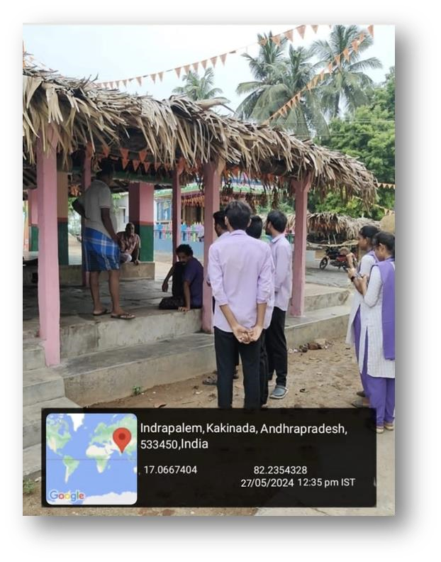

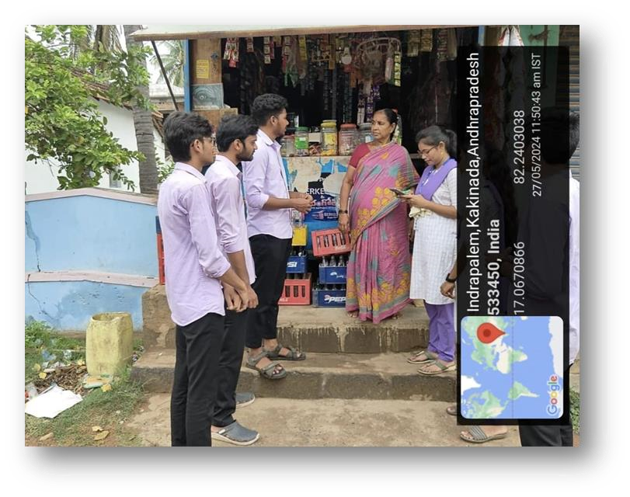

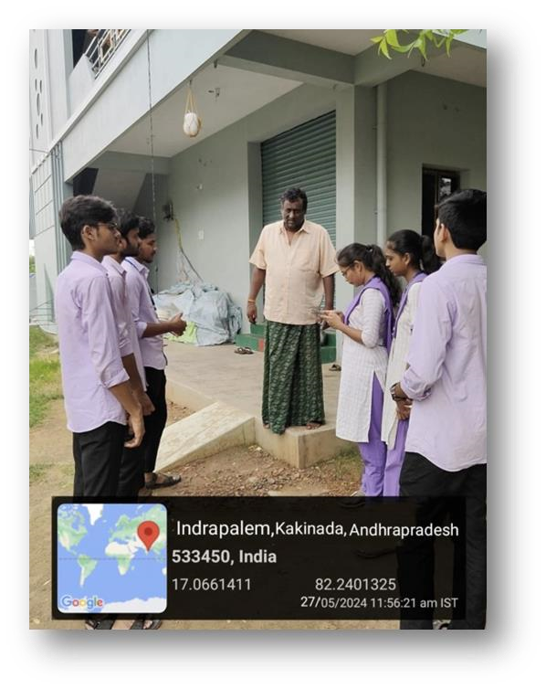

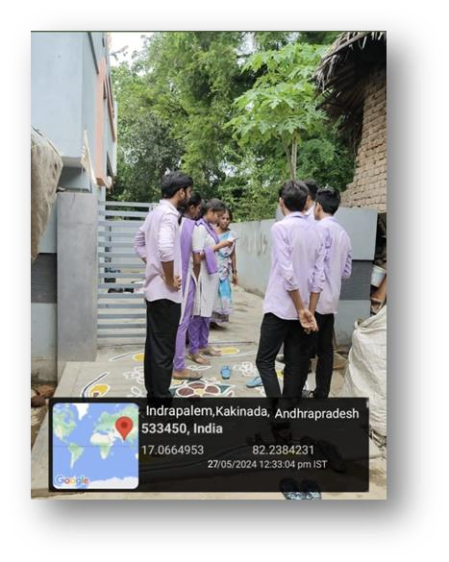

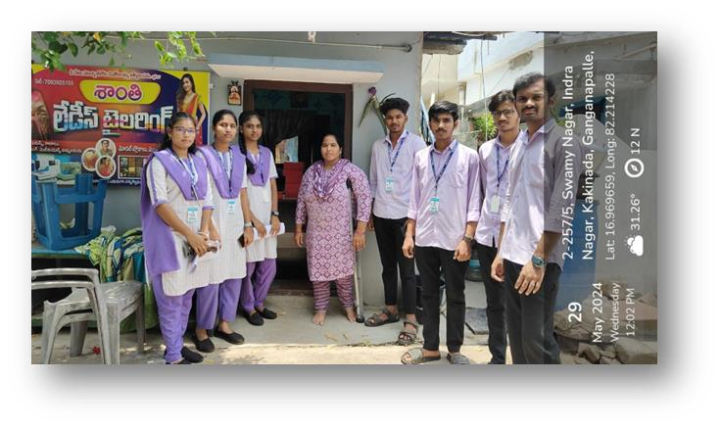

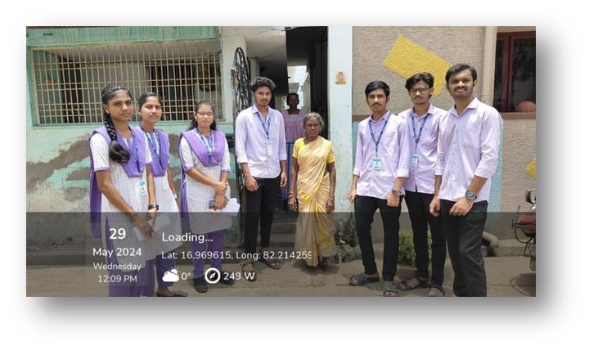

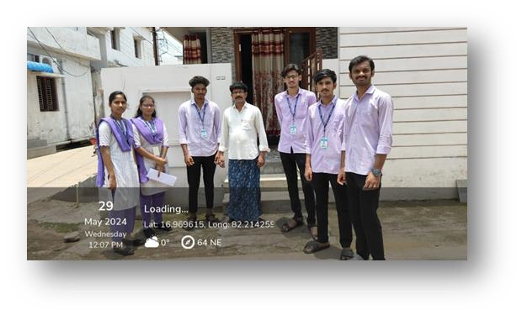

## INTERNAL ASSESSMENT STATEMENT

**(To be used by the Examiners)**

**Name of the Student:** GANTI PETERSON

**Program of Study:** B. Tech

**Year of Study:** II

**Group:** COMPUTER SCIENCE AND ENGINEERING

**Register No/H.T. No:**  23P31A0572

**Name of the College**:ADITYA COLLEGE OF ENGINEERING & TECHNOLOGY

**University:** JAWAHARLAL NEHRU TECHNOLOGICAL UNIVERSITY, KAKINADA

|  |  |  |  |
| --- | --- | --- | --- |
| **Sl.No** | **Evaluation Criterion** | **Maximum**  **Marks** | **Marks Awarded** |
| 1. | Activity Log | 20 |  |
| 2. | Community Service Project Implementation | 30 |  |
| 3. | Mini Project Work | 25 |  |
| 4. | Oral Presentation | 25 |  |
|  | GRAND TOTAL | 100 |  |

Date: Signature of the Faculty Guide

Certified by

Date: Signature of the Head of the Department/Principal

Seal:

## INTERNAL ASSESSMENT STATEMENT

**(To be used by the Examiners)**

**Name of the Student:** BORA VENKAT PRAVEEN REDDY

**Program of Study:** B. Tech

**Year of Study:** II

**Group:** COMPUTER SCIENCE AND ENGINEERING

**Register No/H.T. No:**  23P31A0585

**Name of the College**:ADITYA COLLEGE OF ENGINEERING & TECHNOLOGY

**University:** JAWAHARLAL NEHRU TECHNOLOGICAL UNIVERSITY, KAKINADA

|  |  |  |  |
| --- | --- | --- | --- |
| **Sl.No** | **Evaluation Criterion** | **Maximum**  **Marks** | **Marks Awarded** |
| 1. | Activity Log | 20 |  |
| 2. | Community Service Project Implementation | 30 |  |
| 3. | Mini Project Work | 25 |  |
| 4. | Oral Presentation | 25 |  |
|  | GRAND TOTAL | 100 |  |

Date: Signature of the Faculty Guide

Certified by

Date: Signature of the Head of the Department/Principal

Seal:

## INTERNAL ASSESSMENT STATEMENT

**(To be used by the Examiners)**

BASWA BHAVANA SHANMUKHI

B. Tech

**Year of Study:** II

**Group:** COMPUTER SCIENCE AND ENGINEERING

**Register No/H.T. No:**  23P31A0596

**Name of the College**:ADITYA COLLEGE OF ENGINEERING & TECHNOLOGY

**University:** JAWAHARLAL NEHRU TECHNOLOGICAL UNIVERSITY, KAKINADA

|  |  |  |  |
| --- | --- | --- | --- |
| **Sl.No** | **Evaluation Criterion** | **Maximum**  **Marks** | **Marks Awarded** |
| 1. | Activity Log | 20 |  |
| 2. | Community Service Project Implementation | 30 |  |
| 3. | Mini Project Work | 25 |  |
| 4. | Oral Presentation | 25 |  |
|  | GRAND TOTAL | 100 |  |

Date: Signature of the Faculty Guide

Certified by

Date: Signature of the Head of the Department/Principal

Seal:

ANGULURI BABITHA ESTHER RANI

**Year of Study:** II

**Group:** COMPUTER SCIENCE AND ENGINEERING

**Register No/H.T. No:**  23P31A05A1

**Name of the College**:ADITYA COLLEGE OF ENGINEERING & TECHNOLOGY

**University:** JAWAHARLAL NEHRU TECHNOLOGICAL UNIVERSITY, KAKINADA

|  |  |  |  |
| --- | --- | --- | --- |
| **Sl.No** | **Evaluation Criterion** | **Maximum**  **Marks** | **Marks Awarded** |
| 1. | Activity Log | 20 |  |
| 2. | Community Service Project Implementation | 30 |  |
| 3. | Mini Project Work | 25 |  |
| 4. | Oral Presentation | 25 |  |
|  | GRAND TOTAL | 100 |  |

Date: Signature of the Faculty Guide

Certified by

|  |  |
| --- | --- |
| Date:  Seal: | Signature of the Head of the Department/Principal |

## INTERNAL ASSESSMENT STATEMENT

**(To be used by the Examiners)**

GOGU VENNELA

B. Tech

**Year of Study:** II

**Group:** COMPUTER SCIENCE AND ENGINEERING

**Register No/H.T. No:**  23P31A05A5

**Name of the College**:ADITYA COLLEGE OF ENGINEERING & TECHNOLOGY

**University:** JAWAHARLAL NEHRU TECHNOLOGICAL UNIVERSITY, KAKINADA

|  |  |  |  |
| --- | --- | --- | --- |
| **Sl.No** | **Evaluation Criterion** | **Maximum**  **Marks** | **Marks Awarded** |
| 1. | Activity Log | 20 |  |
| 2. | Community Service Project Implementation | 30 |  |
| 3. | Mini Project Work | 25 |  |
| 4. | Oral Presentation | 25 |  |
|  | GRAND TOTAL | 100 |  |

Date: Signature of the Faculty Guide

Certified by

|  |  |
| --- | --- |
| Date:  Seal: | Signature of the Head of the Department/Principal |

JORUNGU GOPAL RAO

**Year of Study:** II

**Group:** COMPUTER SCIENCE AND ENGINEERING

**Register No/H.T. No:**  23P31A05A6

**Name of the College**:ADITYA COLLEGE OF ENGINEERING & TECHNOLOGY

**University:** JAWAHARLAL NEHRU TECHNOLOGICAL UNIVERSITY, KAKINADA

|  |  |  |  |
| --- | --- | --- | --- |
| **Sl.No** | **Evaluation Criterion** | **Maximum**  **Marks** | **Marks Awarded** |
| 1. | Activity Log | 20 |  |
| 2. | Community Service Project Implementation | 30 |  |
| 3. | Mini Project Work | 25 |  |
| 4. | Oral Presentation | 25 |  |
|  | GRAND TOTAL | 100 |  |

Date: Signature of the Faculty Guide

Certified by

Date: Signature of the Head of the Department/Principal

Seal:

NALLA SIVANANDU

**Year of Study:** II

**Group:** COMPUTER SCIENCE AND ENGINEERING

**Register No/H.T. No:**  23P31A05C0

**Name of the College**:ADITYA COLLEGE OF ENGINEERING & TECHNOLOGY

**University:** JAWAHARLAL NEHRU TECHNOLOGICAL UNIVERSITY, KAKINADA

|  |  |  |  |
| --- | --- | --- | --- |
| **Sl.No** | **Evaluation Criterion** | **Maximum**  **Marks** | **Marks Awarded** |
| 1. | Activity Log | 20 |  |
| 2. | Community Service Project Implementation | 30 |  |
| 3. | Mini Project Work | 25 |  |
| 4. | Oral Presentation | 25 |  |
|  | GRAND TOTAL | 100 |  |

Date: Signature of the Faculty Guide

Certified by

|  |  |
| --- | --- |
| Date:  Seal: | Signature of the Head of the Department/Principal |

VOLETI PAVAN TEJA

**Year of Study:** II

**Group:** COMPUTER SCIENCE AND ENGINEERING

**Register No/H.T. No:**  23P31A05C4

**Name of the College**:ADITYA COLLEGE OF ENGINEERING & TECHNOLOGY

**University:** JAWAHARLAL NEHRU TECHNOLOGICAL UNIVERSITY, KAKINADA

|  |  |  |  |
| --- | --- | --- | --- |
| **Sl.No** | **Evaluation Criterion** | **Maximum**  **Marks** | **Marks Awarded** |
| 1. | Activity Log | 20 |  |
| 2. | Community Service Project Implementation | 30 |  |
| 3. | Mini Project Work | 25 |  |
| 4. | Oral Presentation | 25 |  |
|  | GRAND TOTAL | 100 |  |

Date: Signature of the Faculty Guide

Certified by

|  |  |
| --- | --- |
| Date:  Seal: | Signature of the Head of the Department/Principal |

DUGGUDURTHI SAI RAJANI

**Year of Study:** II

**Group:** COMPUTER SCIENCE AND ENGINEERING

**Register No/H.T. No:**  24P35A0513

**Name of the College**:ADITYA COLLEGE OF ENGINEERING & TECHNOLOGY

**University:** JAWAHARLAL NEHRU TECHNOLOGICAL UNIVERSITY, KAKINADA

|  |  |  |  |
| --- | --- | --- | --- |
| **Sl.No** | **Evaluation Criterion** | **Maximum**  **Marks** | **Marks Awarded** |
| 1. | Activity Log | 20 |  |
| 2. | Community Service Project Implementation | 30 |  |
| 3. | Mini Project Work | 25 |  |
| 4. | Oral Presentation | 25 |  |
|  | GRAND TOTAL | 100 |  |

Date: Signature of the Faculty Guide

Certified by

|  |  |
| --- | --- |
| Date:  Seal: | Signature of the Head of the Department/Principal |